
Graduation Rapport
Johnathan Claasen : 500797643
HBO-ICT Game Development
Johnathan.claasen@hva.nl
06-54906095

September 3, 2024
NLR
Anthony Fokkerweg 2

Abstract
The Virtual Community Noise Simulator (VCNS) is a virtual reality (VR) application developed by the Netherlands Aerospace Centre (NLR) to simulate and assess the impact of aircraft noise on communities. By combining 360-degree video, spatial audio, and 3D aircraft visualization, the VCNS provides an immersive experience used in research studies and public demonstrations. However, the current version relies on high-end, tethered VR hardware, limiting its mobility, accessibility, and ease of deployment.

This research addresses the challenge of adapting the VCNS for standalone VR headsets, specifically the Meta Quest Pro. The primary problem is that transitioning to standalone VR introduces significant technical constraints, including performance limitations, video decoding bottlenecks, spatial audio processing, and file size restrictions. These challenges must be addressed to ensure the VCNS remains immersive and functional on mobile VR platforms.

The central research question of this study is:
"How can the Virtual Community Noise Simulator be adapted to a standalone VR platform while maintaining an optimal balance between performance, realism, and usability?"

To answer this question, the research employs a combination of methods, including a literature review on VR optimization techniques, technical analysis of VR hardware limitations, expert interviews with NLR specialists, and usability testing with participants. The study evaluates video playback performance, spatial audio fidelity, and user interaction to identify bottlenecks and potential solutions for standalone adaptation.

The results show that high-resolution 8K video is too demanding for mobile hardware, requiring bitrate optimization and adaptive resolution scaling to ensure smooth playback. GPU-intensive rendering techniques cause frame drops and overheating, highlighting the need for fixed foveated rendering and dynamic asset streaming. Additionally, file size constraints on standalone VR require efficient storage management solutions, such as Asset Bundles and Addressables, to enable modular content delivery. Usability testing revealed that while the VCNS is functional on standalone VR, improvements in gesture-based interaction, navigation, and system stability are necessary for a seamless user experience.

The study concludes that adapting the VCNS for standalone VR is feasible, but requires targeted performance optimizations and design modifications. By implementing video encoding, memory-efficient spatial audio processing, and GPU-friendly rendering techniques, the VCNS can achieve greater portability and accessibility, expanding its use for aviation noise research, policy discussions, and public engagement.

Contents
Abstract 1
1. Introduction: 5
1.1. Context and Background: 7
1.1.1. Research Goals 7
1.1.2. Research Purpose 7
1.2. Project Scope 8
1.3. Research question 9
2. Research methods 10
2.1. Methods by Sub-Question 10
2.1.1. Research methods Sub conclusion 11
3. The Virtual Community Noise Simulator 12
3.1. VCNS document analysis and Literature Study 14
3.1.1. 360 degree video 15
3.1.2. 3D audio 17
3.1.3. Aircraft Visualization 18
3.2. Limitations of the VCNS 19
3.2.1. Technical Limitations: 19
3.2.2. User Experience limitations: 20
3.2.3. Logistic limitations 20
3.3. Problem Analysis of the VCNS 21
3.3.1. Who is Affected by the VCNS Challenges? 21
3.3.2. What are the Main Problems? 21
3.3.3. Where Do These Problems Manifest? 21
3.3.4. When Do These Issues Arise? 21
3.3.5. Why Are These Problems Significant? 22
3.4. Sub Conclusion 23
4. Enabling Small-Scale Research Studies 24
4.1. Types of Studies 24
4.1.1. Case study: New Airfield Lelystad in the Netherlands 24
4.1.2. Case Study: Increased Glide Slope Procedures at Arlanda, Sweden 24
4.1.3. Case Study: Wind Turbine Noise Simulations 25
4.2. Insights from an NLR Employee 25
4.2.1. Interview Description 25
4.1.2. Execution of a Case Study 25
4.1.3. Technical Limitations 26
4.1.4. Planning 26
4.1.5. Results 26
4.1.6. Reflection 26
4.2. Sub Conclusion 27
5. VR Technology and Platform Analysis for Standalone Adaptation 28
5.1. The evolution of VR 29
5.2. Headset features 30
5.2.1. Passthrough 30
5.2.2. Hand tracking 30
5.2.3. Fixed Foveated Rendering 31
5.2.4. Eye-tracked Foveated Rendering 31
5.2.5. Haptic Feedback 32
5.2.6. Six Degrees of Freedom (6DoF) 32
5.2.7. High-Resolution Displays 32
5.3. VCNS Requirements Prioritisation 33
5.4. Available Product Analysis: VR Platforms & SDK’s 34
5.5. SWOT Analysis: Available VR Platforms 36
5.6. Enhancing Personalization in the VCNS Experience 37
5.7. Brainstorming Future VR Functionality 38
5.8. Sub Conclusion 38
6. Technical challenges: 39
6.1. Application Optimisation 39
6.2. Asset Optimisation 40
6.2.1. Audio Optimisation 40
6.2.2. Video Optimisation 40
6.3. File Size Management 41
6.3.1. Streaming Assets 41
6.3.2. Asset Bundles 41
6.2.3. Addressables 42
6.4. Performance Bottlenecks 43
6.4.1. CPU and GPU Constraints 43
6.4.2. Memory & Storage Limitations 43
6.4.3. Video Decoding Bottlenecks 43
6.5. Sub conclusion 44
7. Development & Testing 45
7.1. The implementation 45
7.1.1. Environment Setup & VR Implementation 45
7.1.2. Reintegration of the VCNS Scene 48
7.1.3. Video Playback Optimization 49
7.1.4. Asset Optimization & File Size Management 50
7.1.5. Spatial Audio 50
7.1.6. Adding User Interface & Scene Loading 51
7.2. Testing 52
7.2.1. First Session: Performance Comparison on Desktop 52
7.2.2. Second Session: Meta Ques Pro APK Test 54
8. Conclusion & Recommendations 56
8.1. Addressing the Sub-Questions 56
8.2. Returning to the Research Question 57
8.3. Recommendations 58
Bibliography 59
Appendix 1 63
VCNS Requirements Prioritisation 63
Available Platform & SDK Analysis 65
Test Plan: Test Session 1 68
Test Plan: Test Session 2 73

1. Introduction:
This report investigates the feasibility of adapting the Virtual Community Noise Simulator (VCNS), a desktop-based VR application developed by the department of Aerospace Operations Sustainability and Environment (AOSE) at the Netherlands Aerospace Centre (NLR), to run on standalone VR devices like the Meta Quest Pro. This application simulates the impact of the aircraft noise on communities using VR, applying 360-degree video and spatial audio to create an immersive experience.
This report serves as the graduation report of Johnathan Claasen for obtaining the title of Bachelor of Science at the Hogeschool of Amsterdam from their HBO ITC Game Development programme. The research falls within the domain of Virtual Reality (VR) development and simulation technologies, with a specific focus on audio-visual simulations for aerospace applications on standalone VR-devices.
Over the last decade, VR simulation has evolved rapidly, transitioning from tethered high-end computing setups such as the Oculus Rift Development Kit (ORDK) to mobile standalone devices like the Meta Quest series, which offer untethered immersive experiences. While these advancements enable greater accessibility and flexibility, adapting high-fidelity simulations like the VCNS to standalone platforms presents significant technical challenges, including performance optimization, asset management and user interaction design.
This research aims to address these challenges by exploring how modern VR technologies can enhance the VCNS’s flexibility and usability while maintaining the high performance and realism required for aerospace noise simulations. In recent years, the integration of 360-degree video and spatial audio into VR applications has become crucial for creating realistic, immersive environments in various industries, including entertainment, healthcare, education, and simulation for industrial purposes (Hamad & Jia, 2022). However, NLR’s VCNS remains constrained by its reliance on tethered headsets, limiting its mobility and practicality for community demonstrations.

Chapter 1 sets the stage by outlining the project’s goals: to adapt the Virtual Community Noise Simulator (VCNS) for standalone VR platforms like the Meta Quest Pro, addressing technical constraints while preserving the simulator’s core functionality.
To systematically tackle this challenge, Chapter 2 details the research methodologies employed. Drawing from the HBO-I Research Methods framework, the study combines literature reviews, expert interviews, technical analyses, and usability testing to answer key sub-questions. This multi-faceted approach ensures the findings are both rigorous and actionable.
Chapter 3 delves into the VCNS itself, dissecting its core components, 360-degree video playback, spatial audio, and 3D aircraft visualization, through document analysis. A problem analysis follows, identifying the simulator’s technical, logistical, and user experience limitations, such as high computational demands, mobility restrictions, and setup complexities. These insights highlight the urgency of transitioning to standalone VR.
The focus then shifts to real-world applications in Chapter 4. Through case studies and interviews with NLR employees, the report illustrates how the VCNS is used in community engagement and small-scale research, such as noise impact assessments for airports and wind turbines. However, the chapter also underscores the VCNS’s current limitations, including hardware portability issues and user interaction barriers, which hinder its broader adoption.
Chapter 5 explores the technological advancements that make standalone VR adaptation feasible. From the evolution of VR hardware to the Meta Quest Pro’s advanced features, like hand tracking, foveated rendering, and passthrough mode, this section evaluates how modern VR capabilities can enhance the VCNS’s functionality and user experience. A SWOT analysis of available VR platforms and SDK’s further solidifies the case for using the Meta SDK as the primary development framework.
The technical hurdles of this transition are addressed in Chapter 6. Key challenges include optimizing 8K 360-degree videos for mobile hardware, managing spatial audio processing, and overcoming performance bottlenecks like GPU overload and memory constraints. Solutions such as adaptive streaming, fixed foveated rendering, and modular asset delivery are proposed to balance fidelity and performance.
Chapter 7 chronicles the development and testing of the standalone VCNS prototype. From setting up the Unity environment to reintegrating core features and troubleshooting deprecated plugins, this chapter provides a candid account of the iterative process. Usability testing with NLR employees reveals both successes (e.g., improved mobility) and areas for refinement (e.g., video watermark distractions).
Finally, Chapter 8 synthesizes the findings, concluding that standalone adaptation is not only feasible but also transformative for the VCNS. By leveraging modern VR technologies and targeted optimizations, the simulator can achieve greater portability and accessibility, expanding its role in aviation noise research and public engagement. The report closes with actionable recommendations for future improvements, ensuring the VCNS remains at the forefront of immersive noise simulation.

1.1. Context and Background:
NLR (The Dutch Aerospace Centre), plays a leading role bridging science, industry, society and government in the field of aerospace in the Netherlands. Through applied research, NLR supports civil and military aerospace development across systems such as satellites, air defence platforms, and weapon systems. Beyond military applications, NLR collaborates with aviation stakeholders like Schiphol Airport, KLM and provides global consultancy in sustainability and environmental impact.
The department of AOSE in which the VCNS has been developed, focuses on the sustainability and environmental aspects of aircraft operations in which they aim to reduce environmental impact of aircraft operations, support the development of sustainable aviation technologies and procedures and provide expertise to the aviation industry and regulatory bodies on sustainability and environmental issues. They also do work with for the European Union (EU) and the ministry of infrastructure and water management, wind park perception studies and so on.

1.1.1. Research Goals
The goals of this research are as follows:
- Investigating the existing VR application and how NLR uses this functionality in its current projects.
- Explore the latest VR technologies available and see how they can help with current and future audio simulation applications.
- Develop a non-tethered native VR application that can be used for various NLR audio simulations.
- Demonstrate one or more new features of the latest VR glasses to show additional benefits of the new solution.
- Write a final rapport on the findings and provide a documented application according to NLR software development guidelines.

1.1.2. Research Purpose
Virtual reality (VR) technology has advanced rapidly in recent years making immersive experiences more accessible to both developers and consumers. An important component of VR immersion is being able to simulate 360-degree environments using both visual and audio elements. These simulations provide users with a sense of presence as if they are truly being there.
Traditional VR applications often rely on powerful, tethered hardware setups, such as high-end laptops or desktop computers, to deliver the necessary performance for rendering high quality 360-degree audio and visuals. Such is the case with NLR and the VCNS.
The VCNS is currently limited to only being used with a tethered VR headset, therefore NLR’s goal is being able to run the VCNS on a stand-alone (a device that can be run in the HMD without the need of a high-end laptop) with a primary focus on the meta quest VR infrastructure.
This research addresses the following question:
"How can mobile VR technology be used to develop a standalone, Virtual Community Noise Simulator for NLR, adapting desktop-based VR practices for a Meta Quest Pro-like headset, enabling small-scale research studies?"

1.2. Project Scope
The transition of the Virtual Community Noise Simulator (VCNS) from a tethered desktop application to a standalone Meta Quest platform represents an important step in advancing NLS’s capacity to conduct immersive, community-centred noise impact studies. This study focuses on adapting the high-fidelity of the VCNS, originally designed for powerful desktop hardware, to the constraints of mobile VR devices while preserving its immersion and realism.
Central to this research is the functional adaption of the VCNS’s core components: its 360-degree video playback system along with its audio engine and aircraft visualization. These elements are foundational to the VCNS’s ability to simulate aircraft flyovers realistically, but their reliance on desktop grade computational power poses significant challenges in a mobile context. For instance, rendering 8k resolution, 360-degree videos on a the Meta Quest Pro’s Android-based hardware requires rethinking video codecs, resolution scaling, and memory management, a process that mirrors broader industry efforts to balance fidelity with performance in mobile VR.
To enhance user interaction, this study explores the integration of the Meta Quest Pro’s modern functionalities like hand and eye-tracking and passthrough. Unlike the original VCNS, which relies on traditional controllers, these features enable more natural interactions, such as gesture-based navigation or gazing capabilities. However, their implementation introduces new technical hurdles, such as optimizing tracking latency to avoid disrupting the simulation’s temporal synchrony between audio and visual cues in order to maintain realism.
This study deliberately excludes modifications to the original desktop-based VCNS, focusing instead on re-integrating existing code and components in a clean environment for a standalone solution using the Unity Engine. While alternative engines like Unreal Engine offer advanced VR toolkits, Unity’s established use in the VCNS’s development ensures continuity and reduces technical debt. Testing will be conducted primarily with NLR employees, a pragmatic choice given their familiarity with the VCNS’s objectives.

1.3. Research question
In order to answer the research question "How can mobile VR technology be used to develop a standalone, Virtual Community Noise Simulator for NLR, adapting desktop-based VR practices for a Meta Quest Pro-like headset, enabling small-scale research studies?" a number of sub-questions must be answered. Here are a few of those questions:
- What are the key features and functionalities of the VCNS that need to be adapted for mobile VR?
- What kind of small-scale research studies can be enabled by developing a stand-alone application for the VCNS?
- What are the technical challenges associated with simulating audio and video in mobile VR applications and how can they be addressed?
- What are modern features and functionalities of meta quest headsets and how can these be applied to improve the VCNS?
These are only a few of the questions that can be asked in order to achieve NLR’s goal. In the following chapter an explanation will be given as to which methods will be used to address each question.

2. Research methods
This chapter outlines the methodology employed to address the research question and sub-questions, guided by the ICT Research methods framework (HBO-i (2018). The Development Oriented Triangulation (DOT) framework is used to ensure that multiple research approaches contribute to a well-rounded understanding of the problem domain. The DOT framework emphasizes design-orientation in ICT research, which aligns with the goal of adapting the VCNS for standalone VR applications. Each sub-question is addressed using appropriate research methods from ICT Research Methods, ensuring that findings are reliable, valid, and practical for implementation. Below each method is explicitly justified based on its relevance to the question.

2.1. Methods by Sub-Question
The first question to be answered is “What are the key features and functionalities of the VCNS that need to be adapted for mobile VR?” This question will be answered by means of document analysis, problem analysis, and literature study.
Document analysis is chosen because the VCNS system has existing documentation detailing its features, capabilities and architecture. This method ensures an objective, structured extraction of technical requirements. Problem analysis is used to identify bottlenecks and constraints in the current VCNS, particularly in terms of computational performance and mobile VR adaption. This helps define which elements need improvement or redesign. Literature study is applied to investigate state-of-the-art audio-visual rendering techniques for VR. Since the VCNS relies heavily on spatial audio and 360-degree video, a literature study ensures the best available solutions are considered for adapting the VCNS to standalone VR.
As for the question “What kind of small-scale research studies can be enabled by developing a stand-alone application for the VCNS?” This question will be answered by means of expert Interviews and document analysis.
Expert interviews allow insights from professionals who currently use the VCNS for research purposes. This method ensures that the new system aligns with real-world needs. Document analysis will review previous case studies and research projects using the VCNS, identifying how a standalone application could support small-scale research studies.
Then for the question “What are modern features and functionalities of meta quest headsets and how can these be applied to improve the VCNS?” Literature study, available product analysis, SWOT analysis and workshop techniques (brainstorming, and requirements prioritisation), will be employed.
Literature study provides insights into current and emerging VR technologies, ensuring that the research is informed by state-of-the-art advancements. Available product analysis evaluates available VR development platforms (e.g., OpenXR, SteamVR, Meta SDK) to determine which are most suitable for VCNS adaption. SWOT analysis (Strengths, weaknesses, opportunities and threats) compares different cross-platform VR frameworks, helping to select the best platform for future development. Workshop techniques will be used to collaboratively identify which VR features are most beneficial to the VCNS.

And finally the question “What are the technical challenges associated with simulating audio and video in mobile VR applications and how can they be addressed?” will be answered by means of community research, good & bad practice analysis, usability and benchmark testing.
Community research gathers insights from developers working with mobile VR and the constraints of developing standalone application. This method leverages open-source communities and forums (e.g., Oculus Developer Hub, Unity forums) to identify common technical issues. Best good & bad practice analysis collects industry-recommended guidelines and optimisation techniques to address known VR development challenges. Usability testing evaluates the prototype’s intuitiveness, comfort, and interaction design through structured sessions with participants (e.g., NLR employees and volunteers), employing tasks such as navigation, scenario selection, and feedback collection via surveys or interviews. Benchmark testing quantitatively measures frame rates, latency, and GPU/CPU usage on pc and mobile VR hardware, ensuring that performance optimizations are effective.

2.1.1. Research methods Sub conclusion
In this chapter, the research methods for addressing the sub-questions were outlined. Document analysis, problem analysis, and literature study will be used to identify the key features of the VCNS that need adaption. Expert interviews and case studies will explore the potential for small-scale research studies enabled by a standalone VCNS. Community research, good & bad practice analysis, usability testing, and benchmark testing will address the technical challenges of simulating audio and video in mobile VR. These methods collectively provide a comprehensive approach to answering the main research question: “How can mobile VR technology be used to develop a standalone, Virtual Community Noise Simulator for NLR, adapting desktop-based VR practices for a Meta Quest Pro-like headset, enabling small-scale research studies?” By employing these methods, the research will ensure that the findings are reliable, valid, and practical for implementation.

3. The Virtual Community Noise Simulator
The Virtual Community Noise Simulator (VCNS) is a critical tool developed by the Netherlands Aerospace Centre (NLR) to simulate the impact of aircraft noise on communities. By combining 360-degree video, spatial audio, and 3D aircraft models, the VCNS provides an immersive audio-visual experience that helps stakeholders understand and mitigate noise pollution around airports. This chapter explores the VCNS’s development, technical features, and practical applications, while also identifying the key challenges that hinder its full potential.
The VCNS originates from 2007, when NLR acquired the first version of the simulator based on NASA’s Community Noise Test Environment (Aalmoes, n.d.). This initial version included an audio hardware solution called Golf-server from AuSIM.inc. Over the years. NLR has made significant improvements to both the software and hardware, transforming the VCNS into a state-of-the-art tool for noise simulation.
The department of Aerospace Operations Sustainability and Environment (AOSE), uses the VCNS with the purpose of demonstrating future changes around airports that impact the noise experience for communities. This simulator presents the user with an audio-visual experience of a simulated aircraft fly-over which is also used in research studies. One of the uses of the VCNS is for community engagement events in the Netherlands and Sweden in which they use the VCNS to demonstrate expected sound characteristics and sound levels (Aalmoes, n.d.).
However, the VCNS is momentarily constrained by several limitations. According to the Federal Aviation Administration, over 5000 aircraft are in the sky during peak times, many of which fly over populated areas during take-off and landing (Air_Traffic_by_the_Numbers_2024.Pdf, n.d.). This underscores the importance of tools like the VCNS in evaluating and mitigating noise annoyance. Yet, the simulator’s reliance on tethered hardware and high-resolution assets poses significant challenges for mobility and performance. For further insights into the VCNS’s challenges, see the research paper discussed in Chapter 4.
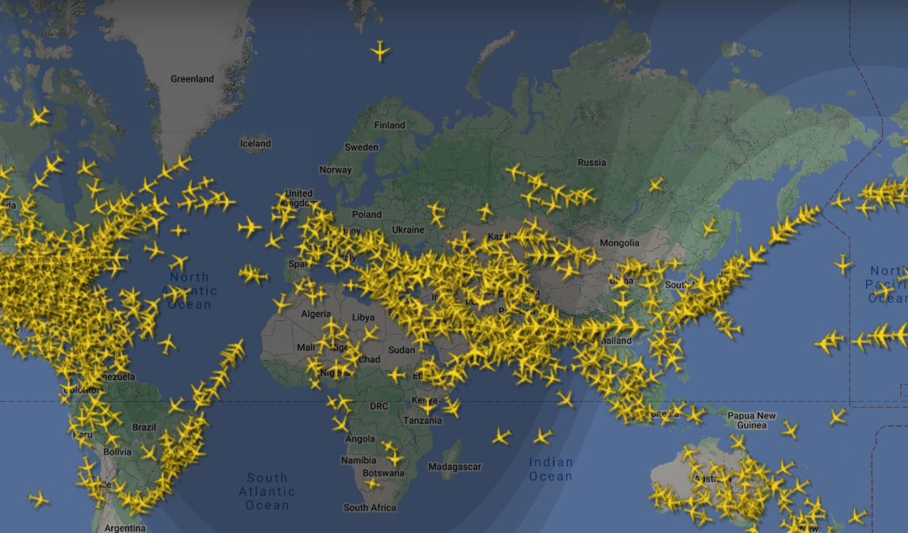
(Figure 1: (Air Traffic By The Numbers | Federal Aviation Administration, n.d.)
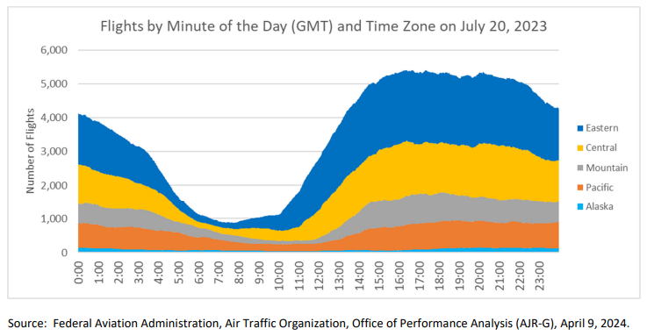
(Figure 2: Federal Aviation Administration, Air Traffic Organization, Office of Performance Analysis (AJR-G), April 9, 2024.)
This chapter employs document analysis and problem analysis to provide a comprehensive understanding of the VCNS. The document analysis reviews existing documentation to explore the simulators development, technical features, and practical applications. The problem analysis identifies and evaluates the key limitations that must be addressed to enhance the VCNS’s usability and effectiveness.

3.1. VCNS document analysis and Literature Study
This section examines the VCNS’s core components and how they contribute to its immersive simulations. The analysis is based on document review of NLR’s internal documentation, technical specifications, and user manuals, as well as literature study of relevant academic and industry sources.
According to VCNS documentation provided by NLR (Aalmoes, n.d.), a demonstration that took place in 2014, that was organised by the government with the purpose to inform the public about the importance of noise impact of aircraft noise in their area. This document also states that two to three VCNS systems were available for demonstrations. Since then similar demonstrations have been conducted over the years using VCNS systems. Bringing these systems to and from demonstrations leads to its own limitations that will further be discussed in the VCNS problem analysis section in sub-chapter
At the core of the VCNS lies flight data, a critical component that breathes realism into the simulation. This data captures the trajectory of an aircraft, recording variables such as GPS coordinates, altitude, speed, and timestamps at precise intervals. When synchronized with 360-degree 8K video footage, ambisonic audio recordings, and 3D aircraft models, this data transforms into an immersive experience that mirrors real-world flight scenarios.

3.1.1. 360 degree video
The VCNS relies on 360-degree video to create immersive environments that simulate aircraft noise impacts. These videos are captured using a 10-camera GoPro rig, which records the environment from multiple angles.
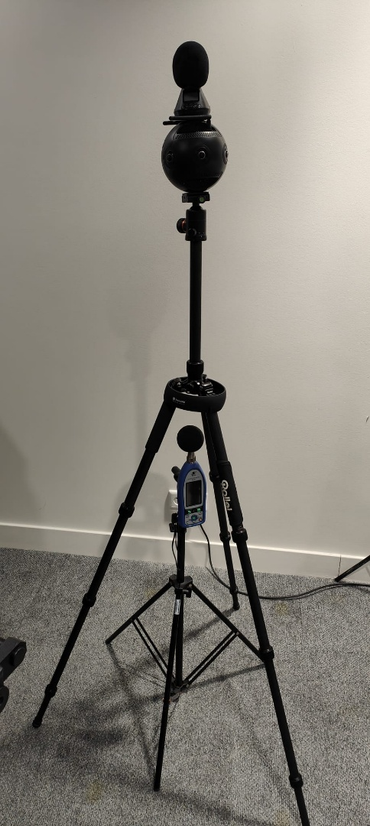
(Figure 3: Photo of a Zoom VR camera used for recordings)

This footage is then stitched together using specialized software to create a seamless spherical video. In Unity, the video is projected onto two spheres. The first sphere is an outer sphere which can be thought of as a skybox (which includes the environment as a background) and is fairly large. The second sphere is smaller, this sphere also displays the 360-degree video file however its purpose is to present objects that are close to the user that block the view of overflying aircraft, such as buildings, trees, billboards and so on. To enable this it uses a mask to remove the objects that are distant, such as the texture of the sky. The reason for this is so that when an object is spawned into the scene that simulates a fly-over (plane/drone/helicopter and so on), it will not look as though the object is flying through buildings or other obstacles.
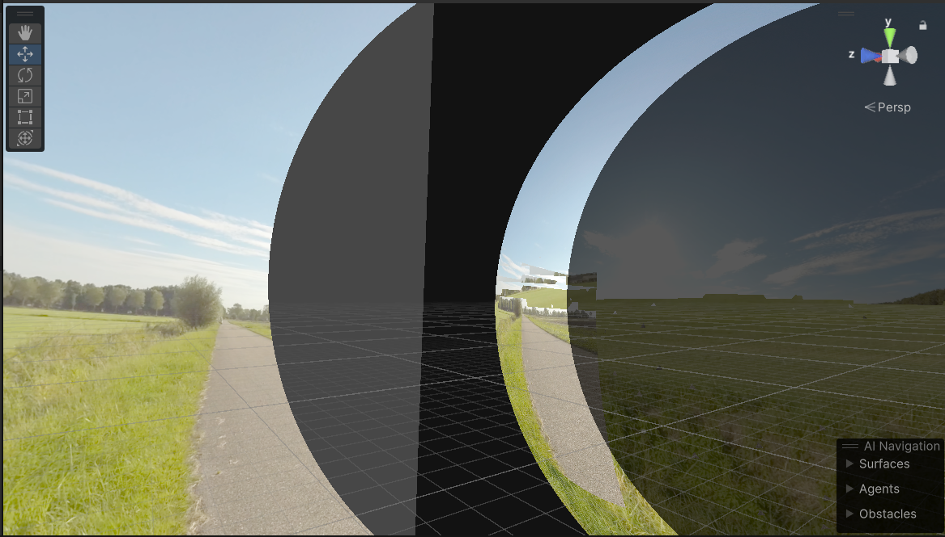
(Figure 4: Image of video representation in the VCNS)
However, this approach brings several challenges. The first challenge is its fixed perspective. Unlike traditional VR environments, 360-degree videos restrict user movement to a single viewpoint. This limitation prevents users from exploring the virtual space freely.
The second challenge is high computational demands. The VCNS uses 8K resolution videos, which require significant processing power and memory. On standalone devices like the Meta Quest Pro, this can lead to performance bottlenecks, such as frame drops.

3.1.2. 3D audio
The VCNS relies on advanced spatial audio techniques to create an immersive and realistic auditory experience. The process involves two key stages: Ambisonic audio recording and binaural audio playback.
The first stage, which is Ambisonic Audio recording, is a full-sphere surround sound technique that captures sound from all directions (360 degrees). In the VCNS, ambisonic audio is recorded using a specialized ambisonic microphone, such as the Zoom VR3 ambisonic recorder. This microphone captures sound in multiple channels, typically in the B-format, which consists of four channels. This 4-channel B-format is also known as first-order ambisonics B-format.
The first channel, which is known as the W, represents the omni-directional polar pattern which contains all sounds in the sphere, coming from all directions at equal gain and phase. The other three channels, X Y Z, represent the directional components of the sound (front-back, left-right, up-down).
These ambisonic recordings are then imported into Unity, where they are used to create a 360-degree audio environment. The ambisonic format allows the VCNS to simulate realistic soundscapes, there the user can perceive the direction and distance of sounds, such as aircraft flyovers.
While ambisonic audio captures sound from all directions, it needs to be converted into a format that can be played back through headphones to create a 3D audio experience. This is achieved using a Head Related Transfer Function (HRTF) (What Is Binaural Audio?, n.d.).
The HTRF simulates how sound waves interact with the human head, ears, and torso, allowing the VCNS to create a binaural audio experience. In Unity, the ambisonic audio files are processed using an HRTF, which converts the multi-channel ambisonic audio into a two channel binaural audio signal. This signal is then played back through headphones, allowing the user to perceive the direction and distance of sounds as if they were in the real environment.
For example. When an aircraft flies overhead in the simulation, the HRTF ensures that the sound appears to come from above and move across the user’s field of hearing, creating a highly realistic and immersive experience.
To better understand the audio pipeline in the VCNS, the following diagram illustrates the process from recording to playback. Sound is captured using an ambisonic microphone (e.g., Zoom VR3) procuring multi-channel ambisonic audio files (B-format). The ambisonic audio files are imported into Unity and processed using an HRTF to convert them into binaural audio and finally the binaural audio is played back through headphones, creating a 3D spatial audio experience for the user.
(Figure 5: Diagram of the audio pipeline)

3.1.3. Aircraft Visualization
The VCNS simulates aircraft flyovers, ranging drones to planes and other aircraft. This aircraft visualization is a core feature of the VCNS, as it allows users to experience the visual and auditory impact of aircraft noise in a controlled environment. The process of simulating an aircraft involves several steps, from loading configuration data to rendering the aircraft and collecting user feedback.
When the VCNS initializes and the simulation starts, configuration files are loaded. These files contain essential data (e.g., aircraft flight data, environmental settings) about the aircraft and the environment. Things like aircraft position determines where the aircraft flyover will take place, environmental settings determine how the environment will be displayed, which video along with its masks, the time of day and much more.
Once the configuration file is loaded, the VCNS renders the aircraft in the virtual environment. The aircraft is represented by a 3D model, which is positioned and animated according to the data from the configuration file. The aircraft’s movement is synchronised with the spatial audio, ensuring that the sound matches the visual representation of the flyover.
The aircraft then follows the flight path which is defined in the configuration files. As it moves the VCNS updates its position, altitude and orientation in real-time, creating a realistic flyover experience. The sound generated by the aircraft is played back through the spatial audio system. The volume and direction of the sound change based on the aircraft’s position relative to the user, enhancing the sense of immersion.
Users can observe the aircraft from a fixed viewpoint, rotating their heads to follow the flyover. The combination of visual and auditory cues allows users to experience the impact of aircraft noise as if they were in a real time environment.
Once the simulation is completed, the aircraft is disabled, and the virtual environment returns to a paused state. A questionnaire is then displayed to collect user feedback. This questionnaire includes questions about the perceived noise levels, but can be expanded in the configuration files for other valuable feedback. To better understand the process of simulating an aircraft flyover, the following diagram illustrates the key steps.
(Figure 6: A flow diagram of a flyover simulation)

3.2. Limitations of the VCNS
The VCNS, faces several limitations that hinder its full potential. These issues effect its transportability, usability, operational efficiency and user experience. The following limitations were identified through document analysis, which involved reviewing past reports, and technical documentation related to the VCNS’s implementation.

3.2.1. Technical Limitations:

3.2.1.1. Video visualisation
Displaying videos in the VCNS has its own limitations. During demonstrations, the VCNS uses high quality video recordings to simulate the realism of an aircraft flyover. These video files can be very large due to the resolution of the video recordings. One example of video files that were used for the VCNS was a 8K resolution video recording that exceeded 40 GB in size.
The problems with video files this large include, first, the size of the file itself and whether it would fit on the device due to the limitations of its storage. Second, the throughput of the video data that is needed to be processed may be too much for the limited processing power of the device. Third, the resolution or refresh rate could be too high for the device to display effectively.
Additionally since the VCNS displays 360 degree videos on a spherical object, it is not possible for the user to walk around in the simulation due to the fact that this would skew the perspective of the environment. On top of that since the VCNS uses multiple spheres to render the environment, this will lead to multiple videos needing to be rendered.

3.2.1.2. Audio Limitations in Immersive Simulations
Audio is a crucial part when making the experience engaging and realistic. Spatial sound must deliver accurate sound localization and clarity to enhance the sense of immersion. As explained previously in Chapter 2, the VCNS uses binaural audio to enhance the experience of the simulation. However doing so limits the capabilities of the simulation. As binaural audio is recorded at a specific point therefore, it is not possible to experience the sound from a different perspective. The user must maintain their position at the location of recording in order to simulate real sound (Pike, n.d.).

3.2.1.3. Build size
The shift towards a standalone format brings new challenges due to the android APK size limitations. According to Google (Optimize Your App’s Size and Stay within Google Play App Size Limits - Play Console Help, n.d.), the limit of a base Android APK should not be bigger than 200 MB, however developers are able to create asset bundles which can be up to 1.5 GB (in total 4 gigabytes including modules and asset packs at the time of installation) each and up to 100 asset packs.
Developers that are part of the Google Play for games partner program however are able to increase the size from 4 to 10 gigabytes (Optimize Your App’s Size and Stay within Google Play App Size Limits - Play Console Help, n.d.).

3.2.2. User Experience limitations:
As the VCNS was built for high-end tethered computer systems, it is not able to run on standalone Android devices. The reliance on cables for power and data transmission obstructs the users movement, as the cable can get in the way, and also limits the mobility of the user as they are not able to walk freely without pulling on the cord or getting it tangled when turning around. This causes a barrier that restricts natural interactions and a sense of presence in the virtual environment.
Another issue has to do with connectivity. While demonstrating the VCNS, some users found that the device would go on stand-by and not waking up correctly while the VCNS was running leading to frustration and a longer test period than intended.
A final issue that sometimes occurs is that while fitting the headset on someone’s head, they accidentally press the power button of the VR device. Especially the Meta Quest Pro headset has a poorly placed location for this button, in a spot where users hold the glasses in order to put them on.

3.2.3. Logistic limitations
Despite the utility of the VCNS, certain challenges limit the efficiency of the simulation. Transporting the hardware to and from events leads is a challenge itself, as the setup requires a minimum of, a high-end laptop (or desktop computer) that can run the simulation, a VR headset which is tethered to said laptop, an audio headset that can emulate the noise, and a high-performance USB Digital-to-Analog Converter (DAC)(Cambridge Audio US, 2016). In order to safely transport said system a suitcase is required to ensure that a VCNS system is not damaged when traveling to and from demonstrations.

3.3. Problem Analysis of the VCNS
This section employs the problem analysis framework (who, what, where, when, why) found on the HBO-I Website(HBO-i, n.d.-b) to evaluate the key challenges faced by the VCNS. The analysis is based on document analysis of NLR’s internal documentation and expert input from NLR employees, including insights from a research paper authored by the interviewed employee (discussed in Chapter 4).

3.3.1. Who is Affected by the VCNS Challenges?
The VCNS was developed and is primarily used by the AOSE department at the Netherlands Aerospace Centre (NLR). This tool is crucial for engaging communities in the Netherlands, but also countries like Sweden, France and the USA by simulating the auditory and visual impact of aircraft flyovers. It is also an essential component in various research studies aimed at understanding noise pollution and its effects. However, several limitations hinder its efficiency, affecting not only the AOSE team but also the community members, policymakers, and researchers who rely on the simulator for accurate and immersive demonstrations.

3.3.2. What are the Main Problems?
The VCNS faces several technical and logistical challenges. Firstly, the size and resolution of the 360-degree video files, often exceeding 40 GB per video, create difficulties in terms of storage and playback on the current hardware. Secondly, the reliance on high-end tethered systems limits the simulator's mobility and user experience, as users are constrained by cables and cannot freely move within the simulation. Thirdly, the binaural audio system, while immersive, requires precise user positioning and the use of headphones, which can detract from the overall experience. Lastly, transporting the bulky and sensitive equipment for community demonstrations introduces logistical hurdles, often leading to connectivity issues and extended setup times.

3.3.3. Where Do These Problems Manifest?
These challenges are most apparent during community engagement events and research studies conducted by the AOSE department. The limitations in video resolution and playback affect the realism of the simulations, particularly in demonstrating the noise impact of aircraft flyovers to communities. The hardware constraints impede the seamless operation of the simulator, especially in outdoor or public settings where tethered systems are impractical. Additionally, the logistical challenges of transporting and setting up the VCNS at various locations further complicate the process, often resulting in delays and technical glitches.

3.3.4. When Do These Issues Arise?
The problems typically arise during the preparation and execution of community demonstrations and research studies. For instance, large video files need to be processed and loaded onto the system well in advance, posing a challenge when dealing with limited storage and processing capabilities. During the actual events, users experience mobility restrictions due to the tethered setup, which can diminish the immersive quality of the simulation. Moreover, connectivity issues and accidental shutdowns of the VR headset, often occurring during demonstrations, disrupt the flow and impact of the presentations.

3.3.5. Why Are These Problems Significant?
The significance of these issues lies in their impact on the effectiveness and efficiency of the VCNS. High-quality, immersive simulations are essential for accurately conveying the noise impact of aircraft flyovers to communities and for collecting reliable data in research studies. The current limitations hinder the ability to deliver such experiences, potentially undermining community trust and the validity of research findings. Furthermore, the logistical challenges and technical glitches increase the time and resources required to conduct each demonstration, reducing the overall productivity and reach of the AOSE department's initiatives.

3.4. Sub Conclusion
The (VCNS) has proven to be a valuable tool for studying the impact of aircraft noise, offering an immersive way to engage with soundscapes that would otherwise be difficult to convey. By combining 360-degree video, spatial audio, and real-time aircraft simulation, it provides a powerful method for researchers, policymakers, and community members to explore noise pollution in a controlled environment. However, despite its strengths, the simulator is currently held back by a number of technical, usability, and logistical limitations that prevent it from reaching its full potential.
One of the most pressing challenges is the technical complexity of the VCNS, which relies on large 360-degree video files, demanding real-time audio processing, and high-end tethered VR hardware. The system’s reliance on high quality 8K video recordings makes it impractical for standalone VR devices, as the sheer file size and processing demands exceed the capabilities of mobile chipsets. Similarly, while the binaural audio system enhances immersion, it also introduces constraints, requiring users to remain in a fixed position for the effect to remain accurate. These limitations pose significant obstacles in adapting the VCNS for more flexible, portable use cases.
Beyond technical constraints, the user experience and operational efficiency of the VCNS also present challenges. The tethered setup restricts movement, reducing the sense of freedom that modern VR applications typically provide. During demonstrations, connectivity issues often arise, causing disruptions that require time-consuming troubleshooting. Even seemingly minor design flaws, such as the poorly placed power button on the Meta Quest Pro headset, have led to interruptions during public presentations.
Logistics further complicate the deployment of the VCNS. The system is designed for high-performance desktop computers, requiring a VR headset, specialized audio equipment, and a Digital-to-Analog Converter (DAC), all of which need to be safely transported in a protective case. Setting up and operating the simulator demands significant preparation, and even small disruptions, such as unstable software performance or hardware malfunctions, can lead to delays in research studies or community demonstrations. These barriers make it difficult to use the VCNS in a wider range of real-world scenarios, particularly in field research settings.
Despite these limitations, there are clear opportunities for improvement that could greatly enhance the simulator’s accessibility, usability, and efficiency. By optimizing video processing, it may be possible to reduce file sizes while maintaining the visual fidelity necessary for accurate noise perception research. Most importantly, transitioning the VCNS to a standalone VR system would significantly improve its mobility, allowing it to be used in more diverse locations without the need for external computers or complex setups.
By overcoming these challenges, the VCNS can evolve into a more flexible and impactful tool, making aircraft noise research more accessible to a wider audience. Enhancing its ease of use and mobility would allow not only researchers and policymakers but also local communities to experience and better understand the effects of aircraft noise firsthand. With these improvements, the VCNS could be used not just in research studies but also in public settings, allowing more people to experience and understand the effects of aircraft noise. This could help raise awareness and contribute to discussions on noise pollution and how it impacts communities

4. Enabling Small-Scale Research Studies
Building on the technical and logistical challenges of the Virtual Community Noise Simulator (VCNS) outlined in chapter 3, this chapter shift focus to the practical applications of the VCNS in small-scale research studies and community engagement. The reliance on high-end hardware, large file sizes, and limitations in user experience, as discussed earlier, hinder the VCNS’s flexibility and accessibility. However, despite these challenges, the VCNS has proven to be a valuable tool in various real-world scenarios, enabling researchers and policymakers to effectively communicate the impact of noise pollution to communities.
This chapter explores how the VCNS has been utilized in different case studies, highlighting its role in community engagement and small-scale research. Additionally, insights from an interview with an NLR employee provide a deeper understanding of the practical challenges and opportunities associated with the VCNS. The goal of this chapter is to demonstrate how the VCNS can be adapted for standalone VR devices, making it more accessible for future research studies.

4.1. Types of Studies
The VCNS has been employed in a variety of research studies and community engagement events, each demonstrating its ability to simulate noise impacts in a realistic and immersive manner. These studies not only showcase the versatility of the VCNS but also highlight its potential for broader applications in noise impact.

4.1.1. Case study: New Airfield Lelystad in the Netherlands
The growth of Amsterdam Airport Shiphol led to the proposal of moving flights to Lelystad Airport, a decision that sparked significant concern among local communities due to the anticipated noise impact of the new flight routes. To address these concerns, the NLR developed simulations for four representative locations: Elburg, Muggenbeet, Dalfsen, and Zwolle. Using the VCNS, the noise impact of an Airbus 319, a representative aircraft for the expected traffic, was demonstrated to the public. The VCNS combined 360-degree video recordings of the locations with binaural audio recordings of the aircraft noise, creating an immersive experience for participants.
At town hall meetings, the VCNS was set up for individual demonstrations, allowing visitors to experience the simulation firsthand. Between 25% and 50% of attendees tried the simulation, with many finding it helpful in understanding the expected noise levels. Some participants even noted that the noise was less severe than they had expected. The VCNS not only provided objective information but also facilitated personal discussions with experts, helping to address concerns and clarify facts. This case study underscores the VCNS’s effectiveness in balancing information from protest groups and providing a realistic simulation of noise impacts.

4.1.2. Case Study: Increased Glide Slope Procedures at Arlanda, Sweden
In Sweden, the VCNS was used to compare the noise impact of a standard 3.0° glide path with a n increased 3.2° glide path at Stockholm’s Arlanda Airport. The simulation focused on a Boeing 737 flying at different altitudes (650m for the 3.0° glide path and 710m for the 3.2° glide path). The VCNS demonstrated both procedures to the community, allowing participants to experience the subtle differences in noise levels.
Approximately 130 people attended the meeting, with about half experiencing the VCNS. Around 30 people then filled in a questionnaire and a majority (77%) indicated that the increased glide slope procedure was less noisy, despite the actual noise difference being only 1 dB)A).
The community found the simulation realistic and trusted the results, highlighting the VCNS’s ability to communicate complex noise data in an accessible manner. This case study demonstrates how the VCNS can be used to evaluate and present the impact of operational changes, such as modified flight procedures, to communities.

4.1.3. Case Study: Wind Turbine Noise Simulations
The transition to renewable energy has led to the increased deployment of wind turbines, which often face opposition due to concerns about noise and visual impact. The VCNS has been employed to simulate the noise and visual impact of wind turbines in various locations, providing communities with a realistic experience with 3D models of wind turbines, along with binaural audio to simulate the directional sound of the turbines.
During community meetings, the VCNS was used to demonstrate the noise impact of wind turbines in relation to ambient noise levels. Some participants found the noise less severe than they had feared, while others remained indifferent or skeptical. The VCNS helped address concerns by providing a realistic simulation of the expected noise levels, reducing uncertainty and offering a clearer perspective on the impact of wind turbines. This case study illustrates the VCNS’s potential for use in a wide range of noise impact studies beyond aircraft noise.

4.2. Insights from an NLR Employee
In order to understand more about the case studies conducted by the department of AOSE, an interview with Naomi Sieben, an employee that works in the field and conducts such studies, was taken. The purpose of this interview was to gain insight on how the VCNS is used and to what extent. Additionally, information could be gained about any technical issues that had occurred during these studies and how users experience the simulation.

4.2.1. Interview Description
During this interview, Naomi, an employee from the department of AOSE shared insights into their work on noise pollution, particularly through the use of the VCNS for case studies. This conversation provided a rich narrative about the intersection of technology, research, and real-world applications in noise pollution.

4.1.2. Execution of a Case Study
"The primary objectives of our studies," the employee explained, "are often shaped by external interests. We frequently collaborate with government institutions, commercial organizations, and even the ministry." They also highlighted internal motivations, noting, "We strive to stay ahead of competitors and push the boundaries of our field."
Research studies take place multiple times a year, typically once or twice. However, the VCNS is regularly used for demonstrations and advising on future endeavours. These case studies often align with internships, lasting around five months. "Each study involves 30 to 40 participants," they noted, "and sessions are carefully structured to include breaks to help maintain focus and concentration."

A notable example of a case study explored drone noise perception (Geluid Juni 2021 - Drones in Bebouwde Omgeving, n.d.). "We designed scenarios where participants experienced drone flyovers," the employee recounted. "In some cases, they only heard the drones, while in others, they both saw and heard them." Interestingly, the study revealed that the level of annoyance was similar whether or not participants could see the drones. "Those who generally dislike drones found the noise equally annoying," they observed.
The studies typically involve participants testing simulations over a session lasting about an hour to ninety minutes, with multiple rounds and small breaks in between to ensure focus and comfort.

4.1.3. Technical Limitations
Technical challenges are a common hurdle during the simulation phase. "VR headset disconnections are a frequent issue," they admitted. "Users sometimes press buttons without understanding the system, leading to unexpected interruptions." Physical challenges, such as cables obstructing movement, further complicate the experience. The open design of the Meta Quest Pro can reduce immersion, as participants can see through gaps in the headset, breaking the virtual reality illusion.
External noise during demonstrations, particularly at events, can also interfere with the effectiveness of the noise simulations. "Poor-quality 360-degree video recordings occasionally compromise the visual aspect of the simulation," they noted. Additionally, the transportation of heavy and cumbersome hardware to various demonstration sites adds logistical difficulties.

4.1.4. Planning
In order for such a study to take place, certain conditions must be met. Often these conditions stem from outside parties with a vested interest in specific subjects, seeking advice. Occasionally, NLR employees, such as Naomi Sieben, drive studies out of personal interest or a desire to maintain a leading edge in their field. "Ethical considerations are always at the forefront of our planning," the employee emphasized. Staying current with the latest tools and techniques is crucial, as the field evolves rapidly.
Recruiting participants is usually the most time-consuming phase of the research study, sometimes taking over a month. Once recruited, the results are collected and then entered into a piece of software called Statistical Package for the Social Sciences (SPSS) for statistical analysis. "SPSS helps us organize, present, and summarize data," they explained, "making it easier to identify differences in variables between different test groups."

4.1.5. Results
Validating simulation results is a meticulous process. "We rely on rigorous data analysis to ensure reliability," the employee explained. Success is measured by how well findings can be applied in real-world contexts. One significant study on drone noise perception (discussed in section 4.1.2) demonstrated that general attitudes toward drones heavily influence noise annoyance levels. "Our findings inform regulatory policies and help improve noise management strategies," they said proudly.

4.1.6. Reflection
Reflecting on the evolution of their approach, the employee shared, "We've learned the importance of early participant recruitment to avoid delays." External factors, such as industry standards and regulations, heavily influence their studies. "Adapting the VCNS with standalone capabilities could significantly increase accessibility and efficiency," they concluded.

4.2. Sub Conclusion
The VCNS has proven to be an invaluable tool in small-scale research studies, particularly in the realm of community engagement and noise perception research. Through its immersive simulations, the VCNS enables stakeholders to experience the auditory and visual impact of noise pollution in a controlled environment, fostering a deeper understanding of proposed changes and their potential effects. However, despite its effectiveness, the VCNS is currently constrained by several limitations, including technical issues such as VR headset disconnections and logistical challenges related to transporting and setting up the system. These limitations hinder its accessibility and usability, particularly in field research settings or community events where mobility and ease of use are paramount.
Transitioning the VCNS to standalone VR devices would address many of these challenges, significantly improving accessibility, reducing setup time, and enhancing the overall user experience. Standalone devices, such as the Meta Quest Pro, offer greater flexibility and portability, allowing the VCNS to be deployed in a wider range of environments without the need for high-end tethered hardware. Furthermore, the integration of modern VR features such as hand tracking and passthrough, could streamline the research process and provide more accurate data collection. For instance, hand tracking eliminates the need for controllers, reducing the risk of accidental button presses and enabling more natural interactions within the simulation. These advancements would not only improve the usability of the VCNS also enhance its ability to deliver realistic and immersive experiences, ultimately supporting more effective community engagement and noise perception research.
Insights from the interview with Naomi further underscore the importance of addressing these limitations. The employee highlighted the logistical difficulties of transporting and setting up the VCNS, which can delay research studies and reduce the system’s overall efficiency. Despite these challenges, the employee expressed optimism about the potential of standalone VR devices to overcome these issues, noting that such a transition would make the VCNS more accessible and flexible, for a wider range of applications.
By addressing its current limitations, the VCNS can evolve into a more accessible and versatile tool, capable of supporting a broader range of research applications and community engagement initiatives. The insights from the NLR employee further reinforce the need for these advancements, highlighting both the challenges and opportunities associated with adapting the VCNS for standalone devices.

5. VR Technology and Platform Analysis for Standalone Adaptation
Building on the insights from chapter 4, which explored the practical applications and limitations of the Virtual Community Noise Simulator (VCNS) in small-scale research studies and community engagement, this chapter shifts focus to the technological advancements that could enable the VCNS’s adaption to standalone VR devices. The case studies and interview with the NLR employee highlighted the challenges of using the VCNS in its current form, particularly its reliance on tethered hardware and the logistical difficulties of transporting and setting up the system. These limitations underscore the need for a transition to standalone VR technology, which offers greater flexibility, portability, and accessibility.
As VR technology continues to evolve, standalone devices such as the Meta Quest Pro have emerged as powerful tools for immersive simulations, offering features like hand tracking, passthrough, and foveated rendering. These advancements not only address the technical and logistical challenges of the VCNS but also open up new possibilities for enhancing its functionality and user experience. This chapter delves into the evolution of VR technology, examining the historical context and modern innovations that have shaped today’s immersive experiences. It also introduces the key features and functionalities of modern VR headsets, evaluating their relevance to the VCNS’s adaption.
However, not all features are equally critical for the VCNS’s adaption. Prioritising these features is essential to ensure a balanced development process that meets the needs of the Netherlands Aerospace Centre (NLR) and the Aerospace Operations, Sustainability and Environment (AOSE) department. To evaluate the suitability of VR technologies and platforms for the VCNS, this chapter employs the following research methods: Requirements prioritization which uses the MoSCoW method to determine the essential features for adapting the VCNS to a standalone VR application. An available product analysis of the available VR platforms and SDKs is conducted to determine the most suitable development environment for the VCNS adaption. Finally a SWOT analysis is performed to evaluate the strengths and weaknesses of the available platforms, as well as opportunities and threats associated with their adoption.

5.1. The evolution of VR
Going back to 1962 this technology started with “head tracking”, meaning users moved only their heads around in able to experience a new reality. The cinematographer Mort Heilig created the Sensorama (which was patented in 1962) that had an arcade like cabinet and a seat that vibrates in able to stimulate all of the users senses. This device featured stereo speakers, a stereoscopic three-dimensional display along with fans and smell generators, and was intended to fully immerse the user in the film.
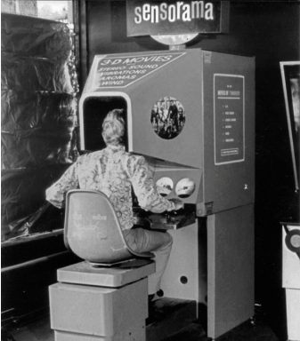
Figure 7: A head-mounted three dimensional display, Sensorama Machine in 1962.
Years later in 1968 Ivan Sutherland created one of first versions of a three-dimensional display in which he presents the user with a perspective image that changes as they move. By placing two-dimensional images this device was able to create the illusion that they are seeing a three-dimensional object (Sutherland, 1968).

5.2. Headset features
Modern VR headsets, such as the Meta Quest Pro, have evolved significantly, offering advanced features that enhance user immersion, interaction, and performance. These features are critical for adapting the VCNS to standalone VR devices, as they enable more natural interactions, improve realism, and optimize performance.

5.2.1. Passthrough
Passthrough is a feature that allows users to see the real world through the VR headset’s cameras, blending the physical and virtual environments. This feature is particularly used for mixed-reality applications, where users need to interact with both virtual and real-world elements simultaneously (Passthrough API Overview, n.d.) “Passthrough provides real-time and perceptually comfortable 3D visualization of the physical world in the Meta Quest Headsets”.
Its relevance to the VCNS is that passthrough could enhance the users experience by allowing users to remain aware of their surroundings during demonstrations. For example, users could interact with physical controls or notes while still experiencing the immersive noise simulation. This feature also improves safety by reducing the risk of collisions with real-world objects when demonstrating at events where there is heavy traffic.

5.2.2. Hand tracking
Hand tracking enables users to interact with the virtual environment using their hands, without the need for controllers. This feature uses cameras and sensors to detect hand movements and gestures, providing a more natural and intuitive interaction method. (Learn about Hand and Body Tracking on Meta Quest | Quest Help, n.d.) “Hand and body tracking allows you to use your hands or controllers to interact with your surroundings. You can play games, watch films and explore without using controllers. It also helps make your avatar’s movements look more realistic”.
Hand tracking can improve the user experience in the VCNS by allowing participants to interact with the simulation using gestures. For instance, users could adjust noise levels, select different aircraft models, or navigate menus using hand movements. This eliminates the need for controllers, making the experience more accessible and immersive.

5.2.3. Fixed Foveated Rendering
Fixed Foveated Rendering (FFR) is a performance optimization technique that reduces the rendering resolution in the peripheral areas of the users vision, where the detail is less noticeable. This allows the headset to allocate more resources to the central area of the displaty, where the user’s focus is concentrated. (Fixed Foveated Rendering (FFR), n.d.) “FFR enables the edges of an application-generated frame to be rendered at a lower resolution than the centre portion of the frame which will lower the fidelity of the scene in the viewers peripheral vision and will likely not be noticed.”
FFR could significantly improve the performance of the VCNS on standalone devices like the Meta Quest Pro. By reducing the rendering load in peripheral areas, the simulator can maintain high frame rates and smooth performance, even when displaying high-resolution 360-degree videos and complex 3D models,

5.2.4. Eye-tracked Foveated Rendering
Eye-Tracked Foveated Rendering (ETFR) takes FFR a step further by dynamically adjusting the rendering resolution based on the user’s eye movements. This ensures that the highest resolution is always focussed on the area where the user is looking, while reducing resolution in other areas. (Eye Tracked Foveated Rendering, n.d.) “Eye Tracked Foveated Rendering (ETFR) utilizes the gaze direction to render full resolution where you are looking at (the foveal region), and low pixel density in the periphery taking advantage of lower peripheral acuity in human vision. The technique reduces the amount of pixels rendered more than when using Fixed Foveated Rendering which leads to better GPU savings.”
EFTR can further enhance the performance and visual quality of the VCNS. By dynamically optimizing rendering based on the user’s gaze, the simulator can deliver a more realistic and immersive experience without overloading the hardware. This is particularly important for maintaining high-quality visuals in resource-intensive simulations.

5.2.5. Haptic Feedback
Haptic Feedback provides tactile sensations to users, enhancing the sense of immersion by simulating physical interactions. This can be achieved through controllers, gloves, or other wearable devices like haptic suits that deliver vibrations or other tactile cues. (Haptics Public Release - Enhance Your Immersive Experiences on Meta Quest, n.d.) “Adding haptics to your VR game or app brings depth and familiarity with the physical world by engaging people’s sense of touch, enabling truly natural interactions with nuanced notifications, realistic clicks, and lifelike textures. Historically, it’s been challenging for sound designers and developers to create haptic experiences for virtual, augmented, and mixed reality apps due to the lack of proper tools—until now.”
While haptic feedback is not currently a core feature of the VCNS, it could be integrated to enhance the realism of the simulation. For example, users could feel vibrations corresponding to the intensity of aircraft noise, adding an extra layer of immersion to the experience.

5.2.6. Six Degrees of Freedom (6DoF)
Six Degrees of Freedom (6Dof) tracking allows users to move freely within the virtual environment, tracking both rotational and positional movements. This enables users to walk around, crouch, and lean, providing a more immersive and interactive experience.
6DoF is essential for the VCNS, as it allows users to explore the virtual environment naturally. For example, users could walk around a virtual neighbourhood to experience the noise impact from different perspectives, enhancing the realism and effectiveness of the simulation. However, the current limitations of the VCNS will not allow the user to move away from their fixed position as the high-resolution 360-degree video needs the user to maintain their position in order to keep realism while viewing the environment. The user IS able to rotate their head and view the environment from a different angle.

5.2.7. High-Resolution Displays
Modern VR headsets, such as the Meta Quest Pro, feature high-resolution displays that provide sharp and detailed visuals. This is crucial for creating realistic and immersive environments, especially in applications like the VCNS that rely on high-quality 360-degree videos and 3D models.
High resolution displays ensure that the VCNS delivers a visually immersive experience, with clear and detailed visuals that enhance the realism of the simulation. This is particularly important for accurately representing the visual impact of aircraft flyovers.

5.3. VCNS Requirements Prioritisation
Adapting the VCNS for standalone VR requires careful prioritisation of features and functionalities. Using the MoSCoW method (Must-have, Should-have, Could-have, Won’t-Have), the requirements were categorized based on their importance, feasibility, and alignment with NLR’s goals.
Must-have Requirements:
These are the essential features that the standalone VCNS must include to function effectively. Examples include core simulation functionality, 360-degree video playback, spatial audio and aircraft visualization.
Should-have Requirements:
These features are important but not critical for the initial release, such as hand tracking, and pass-through.
Could-have Requirements:
These are nice-to-have features that can be deferred to future updates, such as multi-user support and player locomotion.
Won’t-have Requirements:
These features are out of scope for this study, such as support for non-Meta platforms.
A detailed breakdown of the prioritised requirements, including their priority levels, risk assessments, and implementation comments, can be found in the attachments section (Appendix 1, Requirements Prioritization). This analysis ensures that the most critical features are developed first, while less essential features are deferred or excluded, balancing functionality with resource constraints.

5.4. Available Product Analysis: VR Platforms & SDK’s
VR development is essential for creating immersive simulations, enabling realistic interaction and visualisation. Choosing the right VR Software Development Kit (SDK) is critical for accelerating the development cycle of the VCNS (VR SDKs Comparison to Give You a Headstart in VR Development, 2021). These kits provide tools and libraries streamline the integration of hardware, software, and user interaction. To identify the most suitable platform, an Available Product Analysis was conducted, focusing on on Unity XR Interaction Toolkit, VRTK, Meta SDK, Open XR, Open VR, and SteamVR. The findings from the available product analysis , which can be found in the Appendix (Appendix 1, Available Product Analysis), are summarized below in a Summary Table.
Platform | Key features | Pros for the VCNS | Cons for the VCNS
Unity XR Interation Tookit | Cross-platform, pre-built interaction components, Unity Framework | Cross-platform flexibility, Rapid development, active community | Requires specific optimization, limite hardware-specific features
VRTK | Reusable interaction solutions, modular architecture | Efficient prototyping, customizable | Niche community, limited hardware optimization
Meta SDK | Optimized for Meta Quest devices, advanced features (hand tracking, passthrough) | Hardware specific optimization, advanced features, development tools, Building Blocks | Platform specific, tight hardware coupling
Open XR | Cross-platform API, compatible with Meta Quest, SteamVR, Windows Mixed Reality | Cross-platform compatibility, industry support | Custom development required, less hardware-specific optimization
OpenVR | Designed for SteamVR ecosystems, supports various VR headsets | Broad hardware compatibility, flexibility | Limited Meta Quest support, irrelevant for standalone VR
SteamVR | Strong interaction framework, compatible with SteamVR headsets | Broad hardware support, interaction-focused | Not suitable for Meta Quest Pro, limited Meta Quest integration
(Table 1: Summary of VR platforms and SDKs)
Based on the analysis, the Meta SDK (Oculus Integration Plugin) is the most suitable choice for the VCNS due to its deep integration with Meta Quest devices, providing access to advanced features like passthrough, hand tracking, and foveated rendering. It ensures optimized performance and hardware compatibility, which are critical for the VCNS’s high-fidelity simulations. Additionally the option to use Meta Building blocks can improve productivity for developers when prototyping new features (Exploring Meta’s Building Blocks. A Simple Guide for XR Developers | by Satya Dev | Antaeus AR | Medium, n.d.).

The Unity XR Interaction Toolkit offers cross-platform compatibility and pre-built interaction components, making it a strong supplementary tool for reusable interaction solutions. However, it may require additional optimization for Meta Quest- specific features.
OpenXR provides long-term flexibility and scalability, ensuring compatibility with multiple VR platforms. While it supports Meta Quest devices, it may require custom development for advanced features.
VRTK, OpenVR and SteamVR are less suitable for the VCNS due to their focus on non-Meta platforms and tethered VR ecosystems, which do not align with the projects standalone VR requirements. For a detailed breakdown of the pros, cons, and key features of each platform, refer to the Available Product Analysis in the Appendix section (Appendix 1, Available Product Analysis).

5.5. SWOT Analysis: Available VR Platforms
To ensure the best approach for adapting the VCNS to a standalone format, a SWOT (Strength, Weakness, Opportunity, and Threat) analysis was conducted for the various available platforms from the previous section. This analysis evaluates these platforms and SDK’s to determine the most suitable solution for the VCNS. Below is a simplified version of the SWOT analysis which can be found in the Appendix section (Appendix 1, SWOT Analysis: VR SDKS).
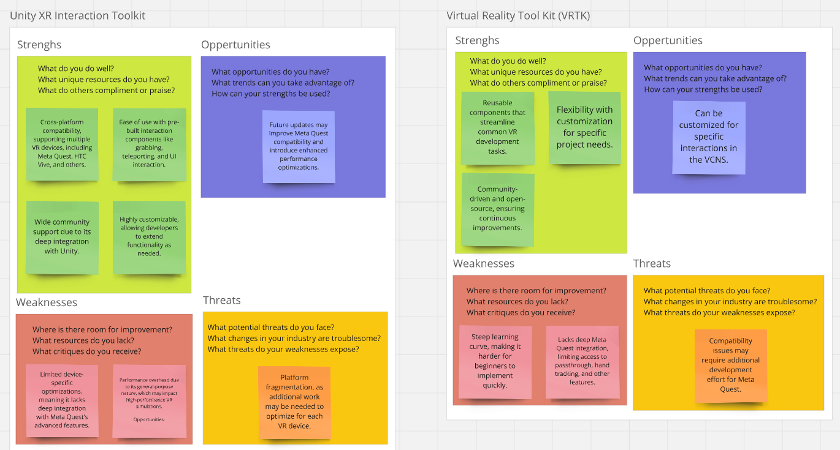
(Figure 7: (Swot Analysis, n.d.))
Based on the SWOT analysis that was conducted from the previously described Available Product Analysis, the Meta SDK stands out as the most suitable choice for developing the VCNS. The Strengths of the Meta SDK, including its deep integration with Meta devices. Provide access to advanced features like passthrough, hand and eye tracking, and foveated rendering, which are essential for enhancing the simulation’s realism and user experience. Additionally, the Meta SDK offers building blocks, an framework with its own template like material that makes it easier to add Meta Quest features and components, that can easily be integrated into the VCNS through the Unity editor.
These features are particularly aligned with the goal of modernising the simulation on the Meta Quest Pro. Additionally, the device optimisation and development tools offered by Met SDK ensure that the simulation not only runs smoothly and efficiently on the target hardware, but allows developers to deploy applications directly to Meta devices or publish to the Meta platform.
There are however, weaknesses to consider. The fact that the Meta SDK is specifically design for Meta Quest devices could limit the ability to expand the VCNS to non-Meta devices. If NLR decides in the future that they want to grow to a broader audience, this could potentially create challenges or risks, leading to major changes needing to be made to the VCNS.

5.6. Enhancing Personalization in the VCNS Experience
To further improve immersion and accessibility, the VCNS can be enhanced with customizable hardware solutions, allowing users to tailor their experience to their personal needs. While the core functionality of the VCNS relies on high-quality visual and auditory accuracy, additional hardware adaptations can enhance comfort, realism, and usability.
One potential upgrade is the integration of moldable earphones, which provide a personalized audio experience by improving sound isolation and ensuring consistent spatial audio perception. (SAFE + SOUND Custom Molded Bluetooth Wireless Earplug Headphones, n.d.). Traditional VR audio solutions rely on over-ear or built-in speakers, which may not always provide optimal noise isolation or individual ear shape adaptation. Moldable earphones offer a custom fit, reducing external noise interference and allowing users to experience aircraft noise simulations more accurately. This enhancement is particularly useful in public demonstrations, where environmental noise could otherwise affect user immersion.
Another personalization option is the development of customized VR glasses or prescription lens inserts (Bigscreen Beyond, n.d.) [Bigscreen Beyond]. Many users rely on glasses, and standard VR headsets may not always accommodate them comfortably. By incorporating adjustable prescription lens adapters, users can engage in longer, more immersive sessions without discomfort. Some VR headsets already support clip-on prescription lenses, eliminating the need for external eyewear and improving visual clarity in simulations.
These personalization options contribute to the VCNS's long-term usability by making it more inclusive and adaptable for a diverse range of users. By optimizing both audio and visual elements, the VCNS can ensure a high-quality, personalized simulation that is accessible for professional researchers, policymakers, and the general public alike.

5.7. Brainstorming Future VR Functionality
During the development of the standalone VCNS, several brainstorming sessions were conducted to explore how modern VR features could enhance the simulation. These discussions focused on potential functionalities such as multi-user support, advanced gesture-based interactions, and real-time environmental adjustments. The goal was to identify ways in which emerging VR technologies could improve both realism and usability, making the VCNS even more immersive and interactive.
While these ideas were well received among stakeholders, the complexity of the project required a clear prioritization of objectives. The primary focus remained on ensuring that the VCNS could successfully transition to standalone VR on Android, addressing key technical challenges such as video playback optimization, resource management, and performance stability. Implementing additional VR features would have introduced further development hurdles, potentially delaying the project’s core objective of making the VCNS functional on the Meta Quest Pro.
Despite this, the brainstorming sessions provided valuable insights for future iterations of the VCNS. The discussions highlighted a strong interest in expanding the simulation’s interactivity and utilizing the full potential of standalone VR hardware once the foundational challenges have been resolved.

5.8. Sub Conclusion
The transition of the VCNS to a standalone VR platform is both necessary and technically feasible, given recent advancements in VR hardware and software. This chapter identified the key technological enablers for this transition, focusing on feature prioritization, and development platform selection and their strengths, weaknesses, opportunities and threats (SWOT).
A critical finding is that not all modern VR features are equally relevant to the VCNS. While functionalities like hand tracking and passthrough can improve interaction and usability, others, such as haptic feedback and six degrees of freedom movement, are less critical due to the fixed-position nature of the 360-degree video simulation. Fixed and eye-tracked foveated rendering were found to be essential for maintaining performance, as they allow the system to allocate resources efficiently, ensuring stable frame rates without compromising visual fidelity.
In evaluating available VR platforms and SDKs, the Meta SDK emerged as the most suitable development environment. Its deep integration with Quest hardware, support for hand tracking and foveated rendering, make it the best fit for adapting the VCNS. While OpenXR and Unity’s XR Interaction Toolkit offer cross-platform flexibility, they lack the direct hardware optimizations provided by the Meta SDK, making them less optimal for this project.
Additionally, this chapter highlighted the importance of hardware customization to enhance accessibility. Moldable earphones improve spatial audio perception, while custom VR lens inserts ensure visual clarity, making the VCNS more inclusive for a broader range of users.
Overall, the analysis confirms that standalone VR adaptation of the VCNS is viable, provided that careful feature selection, performance optimizations, and platform-specific development tools are utilized. The next phase of research will focus on implementing these findings and addressing potential performance bottlenecks to ensure a smooth and immersive standalone VCNS experience.

6. Technical challenges:
Transitioning the Virtual Community Noise Simulator (VCNS) from a high-end desktop application to a standalone Meta Quest Pro headset presents a unique set of technical challenges. While Chapter 5 explored the evolution of VR and the advanced features of modern headsets, this chapter delves into the practical hurdles of adapting the VCNS’s core components, 360-degree video playback, spatial audio, and aircraft visualization, to the constraints of mobile hardware. The shift requires balancing performance and fidelity, ensuring the simulation remains immersive while functioning smoothly on a device with limited processing power, memory, and storage.
This chapter examines these challenges through the lens of community research and industry best practices, identifying optimization strategies that preserve the VCNS’s realism. From video decoding bottlenecks to spatial audio processing, each obstacle underscores the delicate trade-offs required for standalone VR adaption.

6.1. Application Optimisation
Standalone VR devices lack the raw power of high-end PC’s, making optimization a non-negotiable priority. The VCNS relies on real-times rendering of 360-degree environments synchronized with spatial audio, a task that pushes mobile GPU’s to their limits.
To ensure smooth performance on standalone VR devices, it is important that the application is optimized, especially when transitioning from a high-end hardware approach to a more resource-constrained standalone system. Performance issues such as frame drops, latency and long load times can decrease the user experience and immersion of the VCNS. Various optimization techniques can be used to achieve this. Multiple tools are available, and can be used to monitor such aspects. Unity has its own profiler that can be used to monitor the performance while running the application.

6.2. Asset Optimisation
Asset optimisation is essential for achieving high-quality immersive experiences while meeting hardware constraints. Both audio and video assets must be carefully tailored to standalone devices without compromising the realism or immersion.

6.2.1. Audio Optimisation
In VR, the audio experience is just as important as the visualization. Poor audio performance can break the illusion of presence. The audio can be optimized in order to increase performance and retain immersion.
Reducing the audio files without sacrificing quality is important for ensuring a smooth experience on standalone VR devices. By compressing audio files, it is possible to decrease memory usage and processing power requirements, while maintaining adequate sound quality.

6.2.2. Video Optimisation
Poor video performance can directly affect the user immersion. To ensure a realistic fly-over experience, high-quality video is essential, but must be balanced against the limitations of stand-alone VR hardware.

6.2.2.1. Resolution
The resolution of video content plays a critical role in the user experience. While 8k-resolution provides high-quality visuals, it may be too demanding for standalone VR devices like the Meta Quest Pro. A balance needs to be found visual quality and performance. For example, reducing the resolution to 4k can significantly decrease the processing power required while still providing a visually immersive experience. According to [Hosseini & Swaminathan, 2016], adaptive resolution techniques can be applied to dynamically adjust the resolution based on the devices performance, ensuring a smooth experience while maintaining high quality.

6.2.2.2. Bitrate
The bitrate of a video, the amount of data processed per second (measured in Megabits per second), plays a pivotal role in defining both the visual fidelity and the hardware demands of the VCNS. Higher bitrates preserve intricate details, such as the subtle textures of cloud cover or the shimmer of sunlight on an aircraft’s wings, but they come at a cost. Increased file sizes and greater strain on the Meta Quest Pro’s mobile processor and higher bit-rates lead to near-lossless quality which is critical for NLR’s goal of realism. However, this brings the risk of frame drops on standalone VR devices. Large files can strain memory (e.g., a 4k/30 fps video at 100 Mbps can exceed 10 GB).

6.2.2.3. Video Codecs
The VCNS currently uses a specific video codec library for Unity, called AVProWindowsMedia. This video library, or Unity plugin was developed by the studio RenderHeads. AVProWindowsMedia has been deprecated since 2016 as stated by RenderHeads in their community forum ([Released] AVPro Windows Media - Community Showcases - Unity Discussions, n.d.). Not only has this plugin been deprecated for almost 8 years, It has no compatibility with android meaning other solutions need to be found if NLR wants the VCNS to be able to run on stand-alone VR devices. Fortunately the studio Renderheads have been developing other solutions which can be found on the Unity Asset store (RenderHeads Ltd - Asset Store, n.d.) which grants users access to a free trial of the AVProVideo (AVPro Video v3 - Core Mobile Edition | Video | Unity Asset Store, n.d.) plugin.

6.3. File Size Management
The Meta Quest Pro, like all Android-based devices, imposes strict limits on application size, 200MB for the base APK and 1.5GB per additional asset pack (Optimize Your App’s Size and Stay within Google Play App Size Limits - Play Console Help, n.d.). For the VCNS, this is a critical hurdle: a single 8K 360-degree video can exceed 40 GB, while the entire simulation, including 3D aircraft models and ambisonic audio, demands even more space. To reconcile these constraints, three key Unity technologies come into play: Asset Bundles, Streaming Assets, and Addressables. Each offers a different approach to managing file size, but all share the same goal, delivering high-fidelity content without overwhelming the device’s storage.

6.3.1. Streaming Assets
The simplest approach to handling large files in Unity is through Streaming Assets, a built-in system that allows developers to include external files (such as videos or raw data) directly in the application without inflating the initial APK size (Technologies, n.d.-c). Assets placed in the StreamingAssets folder are copied as-is to the device during installation and can be accessed at runtime using either direct file paths or Unity’s UnityWebRequest system.
While this method is straightforward and requires no additional setup, its limitations quickly become apparent when dealing with the VCNS’s massive video files. Since Streaming Assets do not support compression, even a reduced 4K video can still consume 1 GB or more of storage. Additionally, all assets must fit within Android’s 4GB total installation limit, which severely restricts the number of locations or scenarios that can be included in a single build.
For small-scale demonstrations with only a handful of videos, Streaming Assets may suffice. However, for NLR’s needs, where multiple high-fidelity simulations must be readily available, this approach proves impractical. The lack of dynamic loading also means that any updates to video content would require a full app reinstall, creating unnecessary overhead for both developers and end-users.

6.3.2. Asset Bundles
A more flexible alternative is Asset Bundles (Technologies, n.d.-b), which enable developers to package assets into modular, downloadable units. Instead of bundling all content into the APK, critical assets (such as the core application logic and UI) remain in the base installation, while larger files (e.g., environment videos, 3D models) are split into separate bundles. These bundles can then be hosted on a remote server and downloaded on-demand when needed.
This modular approach offers several advantages. First, it drastically reduces the initial APK size, ensuring faster installation and compliance with Google Play’s size restrictions. Second, it allows for dynamic updates—NLR could patch or replace videos without requiring users to download a new version of the app. For example, if a new noise study for Schiphol Airport is conducted, the corresponding video bundle could be updated independently.
However, Asset Bundles introduce their own complexities. Managing remote storage (such as a dedicated NLR server or cloud-based CDN) adds infrastructure overhead, and network dependencies mean that slow or unstable connections could delay asset loading during demonstrations. Additionally, while Unity provides tools for bundle creation and loading, implementing a robust system with error handling (e.g., failed downloads, version mismatches) requires careful engineering.

6.2.3. Addressables
To bridge the gap between simplicity and scalability, Unity’s Addressable Asset System (Simplify Your Content Management with Addressables | Video Game Development, n.d.) combines the best aspects of Streaming Assets and Asset Bundles under a unified framework. Instead of manually managing bundles or direct file paths, developers tag assets with logical labels (e.g., "Lelystad_4K_Video") and let the system handle loading, whether the asset is stored locally, remotely, or even cached after the first download.
The Addressables system excels in scenarios like the VCNS, where flexibility and future-proofing are critical. Core assets (e.g., the VR interaction framework, aircraft models) can be embedded in the APK for instant access, while large videos are hosted remotely. When a user selects a simulation, the system automatically checks for the latest version of the required assets, downloads them if necessary, and caches them for offline use. This ensures that community demonstrations can proceed smoothly even in areas with unreliable internet access.
Addressables simplify updates. NLR could add or modify video content by uploading new files to their server, and the next time the app runs, it would seamlessly fetch the updated assets without requiring user intervention. However, NLR currently does not use a server to load video files meaning it would need to be further looked into. The system also supports dependency management, ensuring that all related assets (e.g., a video and its corresponding audio track) are loaded together.

6.4. Performance Bottlenecks
Transitioning the VCNS to a standalone Meta Quest Pro introduces several performance bottlenecks that impact the application’s smoothness, responsiveness, and overall usability. Unlike high-end desktop VR setups, standalone devices operate with limited processing power, memory, and storage, requiring careful optimization. These bottlenecks stem from CPU and GPU constraints, memory limitations, rendering overhead, and video playback challenges.
This section explores the potential performance bottlenecks in the VCNS, analysing how each factor impacts real-time rendering, interactivity, and immersive simulation quality.

6.4.1. CPU and GPU Constraints
Standalone VR headsets like the Meta Quest Pro rely on mobile chipsets that, while powerful for consumer VR applications, cannot match the performance of high-end desktop GPUs. The VCNS, designed for a tethered PC environment, originally utilized dedicated hardware acceleration to handle complex real-time spatial audio processing, 360-degree video rendering, and high-poly 3D assets.
On standalone devices, CPU and GPU bottlenecks arise when multiple demanding tasks compete for resources simultaneously. The VCNS requires the headset to Render high-resolution 360-degree video in real time. Process spatial audio dynamically for accurate aircraft noise simulation. Handle user interactions and movement tracking without introducing latency.
During real-time execution, spikes in CPU usage can lead to stuttering and frame rate drops, while excessive GPU demand can result in overheating, battery drain, and reduced rendering quality.
To mitigate this, GPU optimization techniques such as fixed foveated rendering (FFR) can be leveraged to reduce processing load in peripheral vision areas while maintaining clarity in the central field of view, ensuring smooth performance without sacrificing immersion.

6.4.2. Memory & Storage Limitations
Another significant bottleneck comes from RAM and storage constraints. The VCNS on a desktop PC had access to at least 16GB of RAM, whereas the Meta Quest Pro is limited to 12GB, with a portion already reserved for the system. Running large 360-degree videos, ambisonic spatial audio, and 3D simulations concurrently could exceed this limit, causing Texture streaming delays (resulting in blurry environments), Longer scene loading times (affecting real-time interaction), and crashes due to insufficient memory allocation.
Additionally, storage constraints affect video playback and asset loading. A single 8K-resolution 360-degree video can exceed 40GB, whereas the Meta Quest Pro enforces a strict 1.5GB limit per asset pack. Without compression and asset streaming, the VCNS cannot accommodate multiple environments within a single build. To address this, memory pooling strategies can be applied to preload and reuse assets efficiently, reducing the memory footprint.

6.4.3. Video Decoding Bottlenecks
Adapting the VCNS for standalone VR presents significant challenges in video decoding, particularly regarding bitrate, frame rate, and resolution. The original desktop version relied on AVProWindowsMedia, a now-deprecated Unity plugin that supported high-bitrate 360-degree video playback. However, this solution was incompatible with Android, necessitating a transition to AVProVideo, which supports mobile hardware but introduces new performance constraints.
The bitrate of a video directly influences its quality, file size, and playback performance. Higher bitrates provide clearer images and finer details, but also require more bandwidth and processing power. On a high-end PC, the VCNS could handle bitrates exceeding 100 Mbps without issue. However, standalone VR headsets such as the Meta Quest Pro impose strict limitations due to hardware decoding constraints and bandwidth management. Key challenges of high-bitrate video on standalone VR include: Increased CPU/GPU load when decoding video in real time. Potential frame drops and stuttering when bitrate exceeds the decoder’s capability. And larger storage requirements, making it difficult to fit multiple scenarios within the Meta Quest Pro’s file size limits.

6.5. Sub conclusion
Adapting the VCNS to standalone VR presents a series of technical hurdles that require careful optimization. Unlike high-end desktop setups, the Meta Quest Pro operates within strict CPU, GPU, memory, and storage constraints, demanding significant adjustments in application architecture.
Performance optimization is essential to maintain frame rates, minimize latency, and prevent overheating. Asset management strategies, including compressed spatial audio and adaptive video resolution, help balance quality and efficiency. The transition from 8K to 4K video, combined with variable bitrate encoding, ensures smooth playback without overwhelming the device’s decoder. Meanwhile, GPU optimizations like fixed foveated rendering help sustain visual fidelity without excessive processing demands.
File size limitations pose another challenge, as standalone VR applications must adhere to strict storage constraints. Implementing streaming assets, asset bundles, and addressables allows for modular content delivery, ensuring that large simulation files remain manageable without sacrificing accessibility.
Despite these challenges, the VCNS can successfully transition to standalone VR by applying a combination of performance optimizations, asset compression, and efficient file management techniques. Addressing these bottlenecks will not only enhance system stability but also ensure that the VCNS remains an immersive and accessible tool for aviation noise research and community engagement.

7. Development & Testing
Developing the standalone version of the Virtual Community Noise Simulator (VCNS) presented numerous technical and logistical challenges. This chapter details the development cycle of the standalone VCNS for the Meta Quest Pro, focussing on the setup of the development environment, the integration of VR capabilities, and the iterative refinement of the application to ensure compatibility and performance. Additionally section 7.2 presents the testing phase of the standalone application and the results gained during testing.

7.1. The implementation
The development of the standalone VCNS began with setting up the necessary tools and Unity environment. This included configuring the Android module and installing the SDK-tools required for building Android applications. A new project was then created using Unity version 2022.3.44.f1, (specifically chosen because of the VCNS currently using a previous version of 2022.3) ensuring compatibility with the latest VR technologies and Android platforms. By limiting the changes in Unity version, the risk of the VCNS breaking due to version differences was minimized.
Essential tools such as Visual Studio Code were installed, along with extensions for development and debugging. Additionally the Meta Quest Link software and Meta Quest Developer HUB (MQDH) were installed to facilitate testing and deployment to the Meta Quest Pro. These tools were critical for enabling VR capabilities and ensuring seamless integration with the Meta Quest ecosystem.

7.1.1. Environment Setup & VR Implementation
Parallel to the technical setup, research was conducted to enhance the realism and functionality of the simulator. Investigating the Meta Quest Pro’s advanced features was a crucial step, as It provided insight into implementing functionalities such as hand tracking, passthrough mode, and interactive environments that seamlessly integrated both hand and controller-based interactions. These features were essential for creating an immersive and user-friendly experience.
Significant effort was also dedicated to optimizing 360-degree video playback. Using Handbrake, a video editing software, various bitrate and resolution configurations were created using the 360-degree videos provided by NLR. This optimization was necessary to ensure smooth performance on the Meta Quest Pro without visual fidelity.
As the goal was to develop a standalone VR experience, the project was immediately set up for the Android platform, ensuring compatibility with the Meta Quest Pro. The XR Plug-in Management was added to the project, along with the Oculus plugin providers for Desktop and Android, ensuring VR-capabilities across platforms. 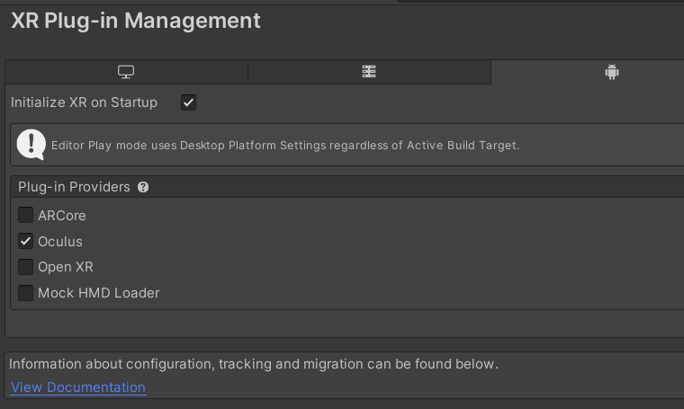
(Figure 8: A screenshot of the XR plug-in management options)
Since the Meta SDK happened to be the development platform the Meta All in One framework (Meta XR All-in-One SDK | Integration | Unity Asset Store, n.d.) was added to the project. Not only did this come with multiple examples on how to integrate specific functionalities like hand tracking, passthrough mode and UI interactions, it allowed developers to quickly prototype modern VR features. This would allow developers to “drag and drop” features into the scene and have samples to experiment with and adjust accordingly.
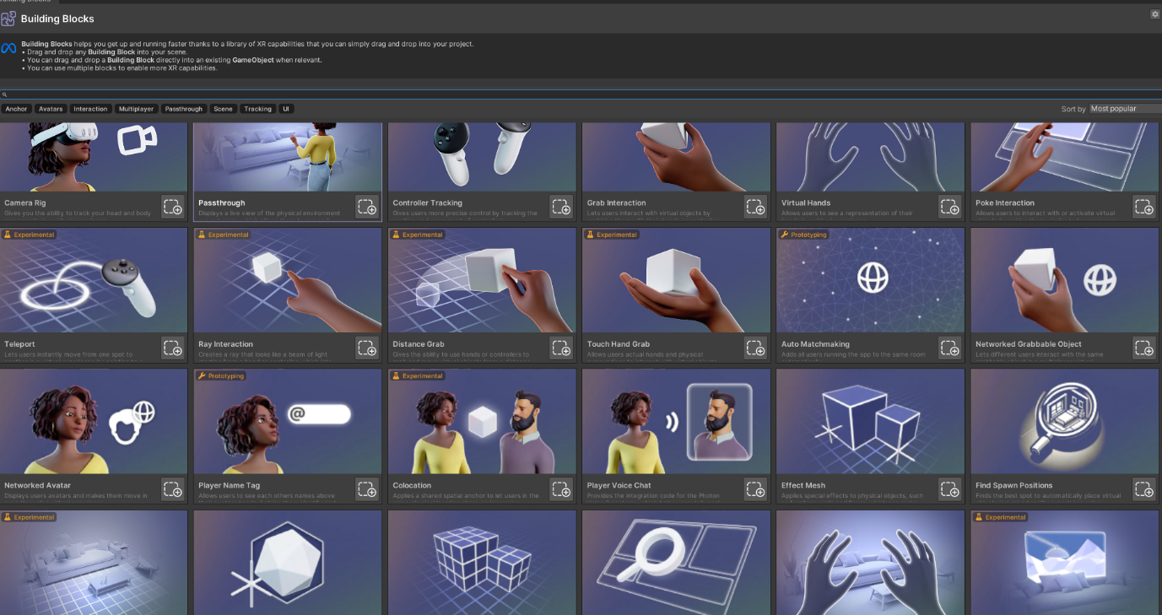
(Figure 9: A screenshot of the Meta Building Blocks available from the Meta All in One SDK)
In order to ensure modern features like Passtrhough and handtracking were enabled in the project. Certain settings on the VR controller needed to be adjusted as can be seen in the following image.
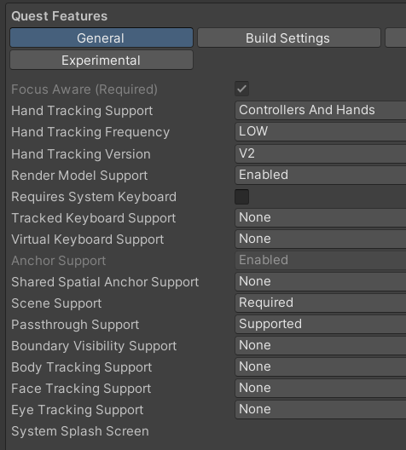
(Figure 10: A screenshot of the VRCamera settings enabling modern features)

7.1.2. Reintegration of the VCNS Scene
The original VCNS scene was then exported along with its dependencies to ensure all necessary components were included. This scene was then imported into the new standalone VCNS project, but the process was not without challenges. A long list of errors emerged, breaking the project entirely and preventing the application from running in the Unity Editor. These errors varied from missing shaders, to broken prefabs (e.g., the VR Player Controller) and missing configuration files and plugins, such as Resonance Audio, which was previously used for binaural audio playback.
To resolve these issues, the missing files were manually located from the VCNS project and added to the standalone version. Broken prefabs were updated by removing missing GameObjects and adding missing scripts and components. This process eventually allowed the application to run in the editor. However, it continued to log a list of Unity errors and warnings that required extensive debugging.
While the project was functional in the Unity Editor, various errors continued to emerge. Many of these issues did not prevent the execution of the application but displayed log errors and warnings to the console, indicating underlying problems that needed to be addressed. These errors were documented and prioritized for further debugging and optimization.

7.1.3. Video Playback Optimization
As mentioned earlier, Handbrake was used to optimize the high quality 8K-resolution videos provided by NLR. This software allowed for the configuration of various video encoding settings, such as resolution, bitrate, and codec, to ensure optimal playback performance on the Meta Quest Pro. The goal was to balance visual quality with performance, ensuring a smooth and immersive experience for users.
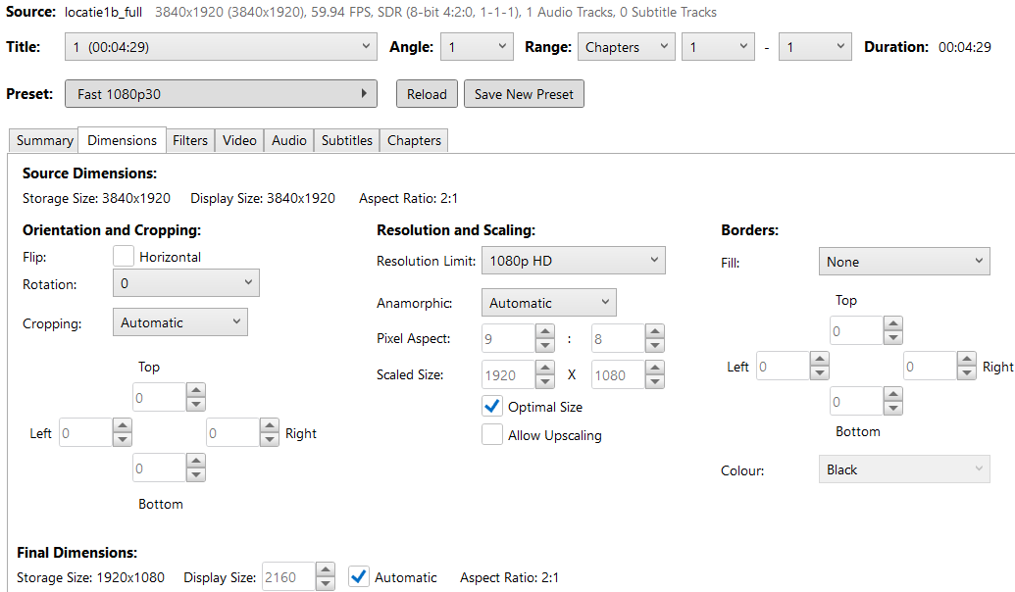
(Figure 11: A screenshot of Handbrake and the render settings of a 360-degree video file)
In order to play these videos in the VCNS, the AVProWindowsMedia plugin for Unity was used.
However, this library, created by RenderHeads, was deprecated in 2016 and lacked compatibility with Android. This posed a significant challenge, as the VCNS heavily relies on this plugin and requires a reliable video playback solution for standalone VR.
To address this, a newer version of the library, which is called AVProVideo and still maintained by RenderHeads, was identified and acquired through the Unity Asset Store. This was a trial version that contained a watermark, however, it offers Android compatibility and continued support, making it a suitable replacement for the deprecated AVProWindowsMedia plugin.
The integration of this new library into the project was a critical step in ensuring the VCNS could function as a standalone application. This also meant that the configuration files for the VCNS needed to be replaced and multiple VCNS scripts were referencing the old library. This led to the conversion of how media files would be managed by the VCNS.

7.1.4. Asset Optimization & File Size Management
One of the most significant challenges in adapting the VCNS for standalone VR was managing asset optimization and file sizes. The original VCNS was designed for high-end desktop hardware. Which allowed for large file sizes and minimal optimisation. However, the Meta Quest Pro has limited storage and memory, requiring careful management of assets to ensure the application could run smoothly.
The 360-degree videos used in the VCNS were originally in 8k resolution, and some even higher, with file sizes exceeding 40 GB per video. To reduce the file sizes, the videos were re-encoded using Handbrake, either by lowering the resolution to 4K and/or adjusting the bitrate to balance quality and performance. This optimisation significantly reduced the file sizes while maintaining acceptable visual fidelity. As the documentation for the AVProVideo plugin suggests that developers add video assets to the streaming assets folder in Unity although it is not recommended to do this with large files.
In order to use the StreamingAssets folder various changes needed to be made to the VCNS configuration scripts. As the original VCNS scripts were loading files from specific folder locations on the desktop version, it led to issues on the Android APK which was one of the main reasons why adapting the VCNS to have standalone capabilities was such a large challenge. Since it is not possible to search for folder locations in an APK, this led to other methods needing to be used. When navigating the StreamingAssets folder Unity advise developers to use the UnityWebRequest method (Technologies, n.d.-d) to locate files. Additionally, the main VCNS scripts needed to be edited to be compatible with android. Additionally, configuration files needed to manually be placed in the correct folder location on the Meta Quest Pro device when installing the APK in order to read from the StreamingAssets folder when running the APK on Android. By changing multiple scripts, the VCNS was able to load from the StreamingAssets folder and run the APK on android devices.

7.1.5. Spatial Audio
Spatial audio is a critical component of the VCNS, as it enhances the realism of the simulation by providing accurate sound localization. The original VCNS relied on the Resonance Audio plugin for ambisonic audio and binaural audio playback. This plugin was also deprecated in 2019 (Technologies, n.d.-a) This required a re-evaluation of the audio pipeline and the integration of a new spatial audio solution. As the Meta All in One plugin came with an audio SDK, it was used chosen to replace the deprecated plugin Resonance Audio. This SDK offers advanced features for spatial audio rendering, making it well-suited for VR applications (Meta XR Audio SDK Overview, n.d.). In the project settings it is possible to change the audio engine making it fairly simple to implement.
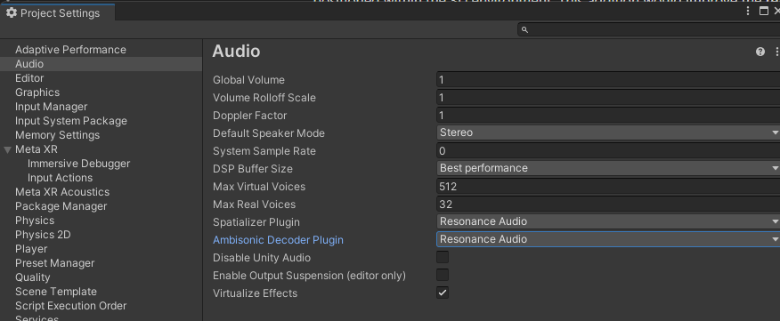
(Figure 12: A screenshot of the audio engine settings in Unity)

7.1.6. Adding User Interface & Scene Loading
By creating a script

As can be seen in the following image .
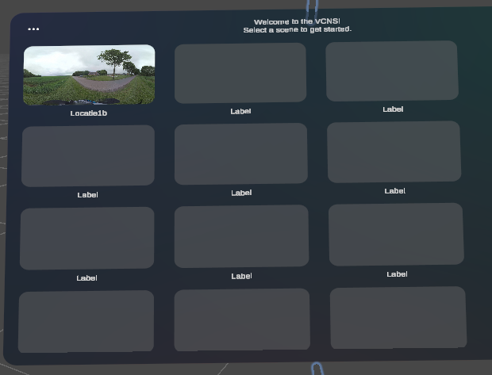
(Figure 13: A screenshot of the UI element used for scene loading)

7.2. Testing
The testing phase of the standalone VCNS was conducted in two sessions, each serving a distinct purpose. The first session focused on a performance benchmark between the original VCNS and the standalone version running on PC. Since the android version was not yet functional at the time, this test provided valuable insights into computational bottlenecks and optimization challenges.
The second session was a usability test, designed to evaluate the standalone VCNS on Meta Quest Pro once the Android APK became available. Unlike the first session, this test focused on user experience, interaction design, and overall immersion rather than raw performance.
A detailed test plan for both sessions can be found in the Appendix section (Appendix 1, Test Plan Session 1)

7.2.1. First Session: Performance Comparison on Desktop
The primary objective of this test was to compare the computational performance of the original VCNS and the standalone-optimized version under controlled conditions. Since the Android version was not yet operational, this session served as a benchmarking study to identify performance differences and optimization areas before transitioning to standalone VR.

7.2.1.1. Preparing the Test Environment
To ensure a fair and controlled comparison, both versions of the VCNS were tested on the same hardware setup—a high-performance Alienware laptop with an RTX 3080 GPU, an Intel i7-11800H CPU, and 16GB of RAM. The Meta Quest Pro, connected via Oculus Link, was used for VR visualization, although the primary focus was on measuring system resource usage rather than user interaction quality.
The test was divided into two distinct phases:
Idle Performance Testing: The VCNS was loaded with only the virtual environment active, but without playing any video content. This provided a baseline measurement of resource consumption when the system was running but not actively rendering an aircraft flyover.
Active Simulation Testing: The aircraft flyover simulation was initiated, playing an 8K 360-degree video with spatial audio. This phase measured how each implementation handled real-time rendering and video playback under full simulation conditions.

7.2.1.3. Results Session One
Observations and Performance Results
From the beginning, it was clear that switching to AVProVideo resulted in noticeable performance improvements, particularly in frame rate stability and CPU efficiency. In the original version, playback of the high-resolution video resulted in frequent frame drops, reducing the fluidity of the simulation. The optimized version, however, maintained a stable 115 FPS throughout most of the test, significantly improving playback smoothness.
CPU utilization saw a major reduction as well. The original VCNS saw CPU usage perform at around 52% during active simulation. In contrast, the AVProVideo implementation efficiently leveraged GPU hardware acceleration, lowering CPU load to a more manageable 50%, even under the same conditions.
GPU usage showed a notable shift as well. The original VCNS underutilized the GPU, with usage hovering around 72% while The AVProVideo version spiked to 79%, increasing GPU utilization.
Memory consumption was another area of significant improvement. The original VCNS consumed over 4 GB of RAM, largely due to inefficient video buffering techniques. The optimized version, however, managed to reduce RAM usage to around 1.8GB, demonstrating better memory allocation and asset management.
While these results were promising, the fact that testing could not be conducted on Android hardware remained a critical concern. The Meta Quest Pro, unlike the high-end laptop used in this test, has a mobile-class GPU, lower processing power, and stricter memory constraints. It remains unknown whether the improvements seen on desktop will translate effectively to standalone VR without further adjustments.

7.2.2. Second Session: Meta Ques Pro APK Test
Once the Android version was operational, a usability test was conducted to assess how intuitive, immersive, and user-friendly the standalone VCNS was on Meta Quest Pro. Unlike the first test, this session did not focus on performance benchmarking but rather on user interaction, navigation, and comfort in a real-world scenario. A more detailed overview can be found in the Appendix (Appendix 1, Test Plan Session 2).

7.2.2.1. Test Setup
The usability test was conducted in a quiet, well-lit space at NLR (the coffee lounge), allowing participants to move freely in VR. The test setup included:
- CPU: intel i7-11800H
- GPU: Nvidia RTX 3080
- Ram: 16GB DDR4
- VR Headset Used: Meta Quest Pro (via Oculus Link)
- Unity Version 2022.3.44.f1
- Video Playback Plugin: AVProVideo
- Video: 8K resolution, 100 mbps, 30 fps
Participants:
Roalt (Advanced VCNS user)
Henk (Intermediate VCNS user)
Other volunteers (mixed experience levels)
Each participant was briefed on the test goals and then allowed to explore the VCNS freely, following structured tasks.

7.2.2.2. Results Session Two
The user testing phase for the standalone VCNS yielded valuable insights into the prototype’s strengths, limitations, and areas for improvement. Conducted with a mix of experienced VR users and first-time participants, including both novice and regular users of the original desktop-based VCNS, the tests focused on realism, usability, and performance across key metrics. Approximately 10 participants were able to give valuable feedback on the prototype. The following image displays the some of the test result in a spreadsheet.
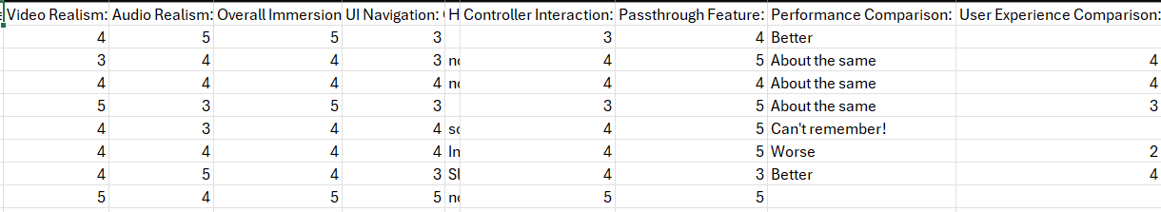
(Figure 15: A screenshot of the usability test results)
Immersive Realism: Audio and Video Fidelity
Participants consistently rated the 360-degree video realism highly, with scores averaging of just above 4/5 and above. One user noted the "photorealistic environment" as a standout feature, while another suggested adding finer details like “waving grass” to enhance naturalism. The spatial audio (binaural) received slightly more varied feedback, averaging just under 4/5. While most praised its directional accuracy, a few users felt the aircraft noise could be more dynamic at different altitudes, indicating room for fine-tuning the audio engine.
Usability: Navigation and Interaction
The UI navigation scored just over 3.5/5, with users appreciating the streamlined menu but occasionally struggling to grab the UI element. Hand tracking, though functional, revealed minor inconsistencies: one participant reported hands "activating scrolling on the UI when trying to press the UI button". In contrast, controller interactions scored higher (4/5), with users finding them intuitive, especially those accustomed to the original VCNS’s mouse-based system. The passthrough feature was universally praised (4.5/5) for its practicality during setup, It allowed users to see the environment before entering the main VCNS scene.
Performance and Comparative Feedback
Compared to the desktop version, the standalone VCNS received mixed but promising evaluations. While some users found performance "about the same," others noted trade-offs: one observed "visual artefacts" absent in the original, while another highlighted the convenience of "not needing a large laptop." Notably, a first-time VR user rated the standalone experience as more immersive due to its untethered design, underscoring the potential of mobile VR for public demonstrations.
Technical Issues and Improvement Suggestions
A few participants encountered minor bugs, such as scenery selection glitches or temporary hand-tracking errors. The most frequent suggestion was to eliminate the video watermark (from the trial version of AVProVideo) and reduce visual artefacts. Others proposed enhancements like integrating the post-simulation questionnaire directly into VR or enabling multi-drone scenarios for complex noise studies.
Conclusion
The standalone VCNS prototype successfully delivered a functional, immersive experience that aligns with NLR’s goals for mobility and accessibility. While the core components, 360-degree video, spatial audio, and aircraft visualization, performed well, the feedback highlights opportunities to refine hand-tracking reliability, UI clarity, and visual fidelity. Addressing these areas, particularly through plugin upgrades and iterative testing, will be critical for ensuring the simulator meets the high standards required for both research and community engagement.

8. Conclusion & Recommendations
This research set out to answer the central question: How can mobile VR technology be used to develop a standalone Virtual Community Noise Simulator (VCNS) for NLR, adapting desktop-based VR practices for a Meta Quest Pro-like headset, enabling small-scale research studies? Through a comprehensive investigation of technical, logistical, and user experience challenges, the study demonstrates that standalone VR adaptation is not only feasible but also offers significant advantages for community engagement and field research.

8.1. Addressing the Sub-Questions
The first sub-question addressed the key features of the VCNS requiring adaptation for mobile VR. As identified in Chapter 3, the simulator’s core components, 360-degree video playback, spatial audio, and aircraft visualization, demand careful optimization to function on standalone hardware. High-resolution 8K videos, while ideal for desktop VR, must be scaled down to 4K to maintain performance on the Meta Quest Pro without sacrificing critical immersion. Similarly, spatial audio processing requires efficient compression and playback techniques to preserve directional sound accuracy. These adaptations ensure the VCNS retains its realism while overcoming the limitations of mobile hardware.
The second sub-question explored the types of small-scale research studies enabled by a standalone VCNS. Chapter 4’s case studies, such as the Lelystad Airport community engagement and Arlanda’s glide slope comparisons, demonstrate the simulator’s effectiveness in real-world applications. A standalone version would expand these use cases by eliminating the logistical barriers of tethered setups, allowing researchers to conduct studies in diverse environments, from town halls to outdoor field sites. The interview with NLR’s Naomi Sieben further emphasized how portability could streamline participant recruitment and testing sessions, making noise impact studies more accessible and efficient.
The third sub-question examined the technical challenges of simulating audio and video in mobile VR. Chapters 5 and 6 revealed that performance bottlenecks, such as video decoding latency and memory constraints, require innovative solutions. Techniques like foveated rendering, asset streaming, and efficient video codecs (e.g., AVProVideo) proved critical in balancing quality and performance. The prototype’s testing sessions (Chapter 7) confirmed that while compromises are necessary, such as reduced video resolution, the standalone VCNS can still deliver a compelling user experience.
The fourth sub-question investigated modern Meta Quest features and their potential to enhance the VCNS. Chapter 5 highlighted how functionalities like hand tracking, passthrough mode, and eye-tracked foveated rendering could improve usability and immersion. For instance, hand tracking enables more natural interactions during community demonstrations, while passthrough mode enhances safety by allowing users to remain aware of their surroundings. These features not only address the limitations of the original tethered system but also open new possibilities for user engagement.

8.2. Returning to the Research Question
Returning to the central research question, this study concludes that mobile VR technology can successfully transform the VCNS into a standalone tool for NLR. The adaptation requires careful optimization of audiovisual assets, leveraging modern VR features, and addressing performance constraints, but the benefits, portability, accessibility, and enhanced user interaction, justify the effort. The prototype’s development and testing confirm that the Meta Quest Pro is a viable platform, capable of delivering realistic noise simulations while supporting small-scale research studies.
However, challenges remain. Further optimization is needed to refine video playback smoothness and reduce latency, while additional usability testing could improve interaction design for non-technical users. Future work should explore cross-platform compatibility and advanced customization options, such as personalizing the audio experience or adaptive rendering for different hardware.
Ultimately, this project advances the field of VR-based environmental simulations by demonstrating how desktop-centric applications can be adapted for mobile platforms. For NLR, the standalone VCNS represents a strategic tool for community engagement and noise research, combining scientific rigor with the flexibility required for real-world impact. By embracing standalone VR, NLR can expand the reach of its noise impact studies, fostering better-informed discussions about aviation’s environmental effects while maintaining the technical excellence that defines its work.

8.3. Recommendations
As the Virtual Community Noise Simulator (VCNS) transitions to standalone VR, several improvements can be made to enhance its usability, realism, and technical efficiency. The research and testing conducted throughout this project have provided valuable insights into potential enhancements that would make the VCNS more immersive, adaptable, and efficient for both researchers and users.
One key area of improvement is personalization. While the VCNS already provides an immersive audio-visual experience, additional hardware customization could make it even more accessible and comfortable for users. Personalized VR accessories such as moldable earphones could improve spatial audio perception by ensuring a better acoustic seal, reducing external noise interference, and enhancing the realism of aircraft noise simulations. Similarly, custom VR lens inserts could provide clearer visuals for users who require prescription glasses, making the simulation more comfortable for extended use. By integrating these modifications, the VCNS can accommodate a wider range of users and offer a more inclusive and tailored experience.
Another enhancement worth exploring is the inclusion of multiple drones in a single simulation. During usability testing, several participants suggested that introducing multiple airborne noise sources could better simulate real-world scenarios, especially in urban environments where drones and aircraft operate simultaneously. This addition would improve the realism and applicability of the VCNS for future studies on noise pollution from both traditional aircraft and emerging aerial technologies.
Further research is also needed into streaming assets as a method to manage large video files efficiently. One of the biggest challenges of transitioning the VCNS to standalone VR is the file size limitations imposed by Android-based headsets. Currently, high-resolution 360-degree videos must be stored within the application, taking up significant space. By implementing a server-based asset streaming system, the VCNS could load videos dynamically, reducing APK and bundle sizes while maintaining high-quality video playback. This approach would not only allow for greater flexibility in adding new simulations but also ensure that the VCNS can scale without being restricted by storage constraints.
Additionally, improvements must be made to the codebase to fully integrate VR-based interactions. Many features in the original desktop version of the VCNS rely on keyboard inputs, such as pressing a key to display an aircraft’s flight path. In a VR environment, these functionalities need to be translated into intuitive interactions using hand tracking, controller inputs, or menu-based options. Ensuring that all essential desktop functionalities are seamlessly adapted to VR is critical for maintaining the usability and effectiveness of the simulator.
By implementing these improvements, the VCNS can evolve into a more refined, realistic, and flexible simulation tool. Personalization features will make it more accessible and comfortable, enhanced simulation capabilities will increase realism, and technical optimizations will improve scalability and user interaction. These recommendations provide a foundation for future development, ensuring that the VCNS continues to serve as a leading tool for aircraft noise research and public engagement.

Bibliography
Aalmoes, R. (n.d.). Virtual Reality Aircraft Noise Simulation for Community Engagement.
Air Traffic By The Numbers | Federal Aviation Administration. (n.d.). Retrieved 25 March 2025, from https://www.faa.gov/air_traffic/by_the_numbers
Air_Traffic_by_the_Numbers_2024.pdf. (n.d.). Retrieved 3 March 2025, from https://www.faa.gov/air_traffic/by_the_numbers/media/Air_Traffic_by_the_Numbers_2024.pdf
AVPro Video v3—Core Mobile Edition | Video | Unity Asset Store. (n.d.). Retrieved 13 March 2025, from https://assetstore.unity.com/packages/tools/video/avpro-video-v3-core-mobile-edition-278892
Bigscreen Beyond. (n.d.). Bigscreen. Retrieved 13 March 2025, from https://store.bigscreenvr.com/products/bigscreen-beyond
Cambridge Audio US. (2016, February 3). https://www.cambridgeaudio.com/usa/en/blog/what-is-a-USB-DAC
Exploring Meta’s Building Blocks. A Simple Guide for XR Developers | by Satya Dev | Antaeus AR | Medium. (n.d.). Retrieved 13 March 2025, from https://medium.com/antaeus-ar/exploring-metas-building-blocks-d99fdd1b3ec3
Eye Tracked Foveated Rendering. (n.d.). Retrieved 13 March 2025, from https://developers.meta.com/horizon/documentation/unity/unity-eye-tracked-foveated-rendering/?intern_source=devblog&intern_content=save-gpu-with-eye-tracked-foveated-rendering
Fixed foveated rendering (FFR). (n.d.). Retrieved 13 March 2025, from https://developers.meta.com/horizon/documentation/unity/os-fixed-foveated-rendering/
Geluid Juni 2021—Drones in bebouwde omgeving. (n.d.).
Hamad, A., & Jia, B. (2022). How Virtual Reality Technology Has Changed Our Lives: An Overview of the Current and Potential Applications and Limitations. International Journal of Environmental Research and Public Health, 19(18), Article 18. https://doi.org/10.3390/ijerph191811278
Haptics Public Release—Enhance Your Immersive Experiences on Meta Quest. (n.d.). Retrieved 13 March 2025, from https://developers.meta.com/horizon/blog/haptics-public-release-enhance-your-immersive-experiences-on-meta-quest/
HBO-i. (n.d.-a). HBO-i (2018). ICT Research Methods—Methods Pack for Research in ICT. ICT Research Methods. Https://ictresearchmethods.nl/. ICT Research Methods. Retrieved 3 March 2025, from https://ictresearchmethods.nl/
HBO-i. (n.d.-b). ICT Research Methods—Methods Pack for Research in ICT. ICT Research Methods-Problem Analysis. Retrieved 24 March 2025, from https://ictresearchmethods.nl/field/problem-analysis/
Learn about Hand and Body Tracking on Meta Quest | Quest help. (n.d.). Retrieved 13 March 2025, from https://www.meta.com/en-gb/help/quest/290147772643252/?srsltid=AfmBOoqmo0N_4o0wq7icig_GC7iz74955CUn74s7FOkV6DY8RtRoD5j4
Meta XR All-in-One SDK | Integration | Unity Asset Store. (n.d.). Retrieved 13 March 2025, from https://assetstore.unity.com/packages/tools/integration/meta-xr-all-in-one-sdk-269657?srsltid=AfmBOorC3AwVyEgdujotYAJktLLBOcmz0QNgWI0pfPr6tgeDhmfpaiu-
Meta XR Audio SDK Overview. (n.d.). Retrieved 13 March 2025, from https://developers.meta.com/horizon/documentation/unity/meta-xr-audio-sdk-unity
Meta XR Audio SDK (UPM). (n.d.). Retrieved 13 March 2025, from https://developers.meta.com/horizon/downloads/package/meta-xr-audio-sdk/
Optimize your app’s size and stay within Google Play app size limits—Play Console Help. (n.d.). Retrieved 13 March 2025, from https://support.google.com/googleplay/android-developer/answer/9859372#size_limits
Passthrough API Overview. (n.d.). Retrieved 13 March 2025, from https://developers.meta.com/horizon/documentation/unity/unity-passthrough/
Pike, C. W. (n.d.). Evaluating the Perceived Quality of Binaural Technology.
[Released] AVPro Windows Media—Community Showcases—Unity Discussions. (n.d.). Retrieved 13 March 2025, from https://discussions.unity.com/t/released-avpro-windows-media/480435
RenderHeads Ltd—Asset Store. (n.d.). Retrieved 13 March 2025, from https://assetstore.unity.com/publishers/780
SAFE + SOUND Custom Molded Bluetooth Wireless Earplug Headphones. (n.d.). Decibullz. Retrieved 13 March 2025, from https://decibullz.com/products/safe-sound-wireless-headphones-moldable-earpieces
Simplify your content management with Addressables | Video game development. (n.d.). Unity. Retrieved 3 March 2025, from https://unity.com/how-to/simplify-your-content-management-addressables
Sutherland, I. E. (1968). A head-mounted three dimensional display. Proceedings of the December 9-11, 1968, Fall Joint Computer Conference, Part I, 757–764. https://doi.org/10.1145/1476589.1476686
Swot Analysis. (n.d.). Miro.Com. Retrieved 25 March 2025, from https://miro.com/app/board/uXjVIZKW1wA=
Technologies, U. (n.d.-a). Google Resonance Audio—Unity Manual. Retrieved 13 March 2025, from https://docs.unity3d.com/es/2019.4/Manual/com.unity.google.resonance.audio.html
Technologies, U. (n.d.-b). Unity - Manual: AssetBundles. Retrieved 25 March 2025, from https://docs.unity3d.com/6000.0/Documentation/Manual/AssetBundlesIntro.html
Technologies, U. (n.d.-c). Unity - Manual: Streaming Assets. Retrieved 13 March 2025, from https://docs.unity3d.com/2023.2/Documentation/Manual/StreamingAssets.html
Technologies, U. (n.d.-d). Unity - Scripting API: UnityWebRequest. Retrieved 13 March 2025, from https://docs.unity3d.com/6000.0/Documentation/ScriptReference/Networking.UnityWebRequest.html
VR SDKs Comparison to give you a Headstart in VR Development. (2021, February 26). DEV Community. https://dev.to/chelash/vr-sdks-comparation-to-give-you-a-headstart-in-vr-development-lfa
What Is Binaural Audio? Immersive Audio Deep Dive. (n.d.). Audiocube. Retrieved 25 March 2025, from https://www.audiocube.app/blog/what-is-binaural-audio

Definitions:
NLR | Netherlands Aerospace Centre
AOSE | Aerospace Operations Environment and Sustainability
VCNS | Virtual Community Noise Simulator
VR | Virtual Reality
HMD | Heads Mount Display
NASA | National Aeronautics and Space Administration
CNOTE | Community Noise Test Environment

Appendix 1

VCNS Requirements Prioritisation
Requirement | Category | Priority | Risk Level | Comments
Core Simulation Functionality | Must-have | High | Low | Essential for maintaining the VCNS’s primary purpose (noise simulation).
360-Degree Video Playback | Must-have | High | Medium | Requires optimization for 4K resolution to ensure performance on Meta Quest Pro.
Spatial Audio (Ambisonic/Binaural) | Must-have | High | Medium | Must support dynamic sound perspective for standalone VR.
Basic VR Interactions (Look, Select) | Must-have | High | Low | Enables users to navigate and interact with the simulation.
Meta Quest Pro Compatibility | Must-have | High | Low | Ensures the application runs on the target hardware.
Hand Tracking | Should-have | Medium | Medium | Enhances user interaction but not critical for core functionality.
Passthrough Mode | Should-have | Medium | Medium | Useful for mixed-reality applications but not essential for noise simulation.
Eye-Tracked Foveated Rendering | Should-have | Medium | High | Improves performance but requires significant development effort.
Advanced Aircraft Visualization | Could-have | Low | Medium | Adds realism but may strain standalone hardware.
Customizable Noise Scenarios | Could-have | Low | Low | Allows users to adjust noise levels but not critical for core functionality.
Non-Meta Platform Support | | Won’t-have | N/A | High | Focus is on Meta Quest Pro; other platforms are out of scope for this study.
Multi-User Support | Won’t-have | N/A | High | Useful for collaborative studies but not a priority for initial release.

Explanation of Prioritisation
Must-have Requirements
These are the essential features that the standalone VCNS must include to function effectively:
- Core Simulation Functionality: The VCNS must retain its ability to simulate aircraft noise impacts accurately.
- 360-Degree Video Playback: High-quality video is crucial for immersion, but resolution must be optimized for standalone hardware.
- Spatial Audio: Dynamic sound perspective is necessary to maintain realism in standalone VR.
- Basic VR Interactions: Users must be able to look around and select options within the simulation.
- Meta Quest Pro Compatibility: The application must run smoothly on the target hardware.
Should-have Requirements
These features are important but not critical for the initial release:
- Hand Tracking: Enhances user interaction but can be added in a later update.
- Passthrough Mode: Useful for mixed-reality applications but not essential for noise simulation.
- Eye-Tracked Foveated Rendering: Improves performance but requires significant development effort.
Could-have Requirements
These features are nice-to-have but can be deferred to future updates:
- Advanced Aircraft Visualization: Adds realism but may strain standalone hardware.
- Multi-User Support: Useful for collaborative studies but not a priority for initial release.
- Customizable Noise Scenarios: Allows users to adjust noise levels but is not critical for core functionality.
Won’t-have Requirements
These features are out of scope for this study:
- Non-Meta Platform Support: The focus is on the Meta Quest Pro; other platforms are not considered.

Available Platform & SDK Analysis
To determine the most valuable platform for the development of the Standalone Virtual Community Noise Simulator (VCNS) for the Meta Quest Pro, the following VR platforms and SDK’s were evaluated:
Unity XR Interaction Toolkit
The unity XR interaction Toolkit is a comprehensive framework provided by Unity for VR and AR development. It simplifies the development of VR applications by offering pre-built interaction components such as grabbing, teleporting and UI interaction and is cross-platform.
key features are cross-platform support (Meta Quest, HTC Vive, Windows Mixed Reality). It comes with pre-built components for common VR interactions like grabbing, locomotion and UI interaction.
Pros:
- Cross-platform flexibility: suitable for future expansion beyond Meta Quest Pro.
- Rapid development: Pre-built components accelerate prototyping and implementation.
- Active community: Extensive support and resources from Unity’s developer base.
Cons:
- Platform-specific optimization: may require additional effort to leverage Meta Quest Pro’s advanced features (e.g., eye tracking, hand tracking, passthrough).
- Limited hardware-specific features: Not as tailored to Meta Quest devices as the Meta Quest SDK.

Virtual Reality Toolkit
VRTK is a Unity-based toolkit offering reusable solutions for common VR development tasks, such as movement, object interaction and UI navigation.
Key features are reusable solutions for common VR interactions like locomotion (movement) and object interaction. Modular architecture for custom solutions.
Pros:
- Efficient prototyping: Focuses on reusable interaction solutions.
- Customizable: Modular design allows for tailored implementations.
Cons:
- Niche community: Smaller developer base compared to Unity XR and Meta SDK.
- Limited hardware optimization: Less focus on Meta Quest specific features.

Meta sdk
Oculus integration plugin (currently known as Meta SDK) is a platform-specific SDK for developing applications for the Oculus devices, including the Quest series. It provides tools for optimized performance on Oculus hardware including features like spatial tracking and hand gestures.
Meta sdk also offers a Unity extension called Building Blocks. Building Blocks are designed to help developers quickly discover Meta Quest features that can then be added to the application. Each Building Block represents a specific VR feature (e.g., interaction features, multiplayer, passthrough and so on).
Key features are Meta SDK is optimized for Meta Quest devices, It integrates advanced features like hand tracking, passthrough and foveated rendering, gives developers the ability to use Building Blocks and has the development tools to help optimize performance.
Pros:
- Hardware-specific optimization: Ensures smooth performance on Meta Quest Pro.
- Advanced features: Full access to Meta Quest Pro’s unique capabilities (e.g., hand tracking, passthrough, foveated rendering).
Cons:
- Platform-specific: Limited to Meta devices, reducing cross-platform flexibility.
- Tight hardware coupling: Applications are tied to Meta Hardware, limiting future expansion.

OpenXR
OpenXR is an open standard API for VR and AR development designed to unify the VR development process across multiple hardware and software platforms. It is also compatible with platforms like SteamVR, Oculus, and Windows Mixed Reality.
Key features include industry-standard API for cross-platform VR and AR development and is compatible with the Meta Quest, SteamVR and Windows Mixed Reality platforms.
Pros:
- Cross-platform compatibility: Ensures long-term flexibility and scalability.
- Industry support: Backed by major VR hardware and software providers.
Cons:
- Custom development required: Advanced Meta Quest Pro features may need additional implementation.
- Less hardware-specific optimization: Not as tailored to Meta Quest devices as the Meta SDK.

OpenVR
OpenVR is a software development kit (SDK) which was also developed by Valve with the focus on supporting Steam VR devices handling display, tracking and input for OpenVR devices.
Key features include being designed for SteamVR ecosystems (e.g., HTC Vive, Valve Index) and supports various VR hardware.
Pros:
- Broad hardware compatibility: suitable for multi-device VR applications.
- Flexibility: Works with Steam-compatible headsets.
Cons:
- Limited Meta Quest Support: Not optimized for standalone Meta Quest devices.
- Irrelevant for standalone VR: Focuses on tethered VR ecosystems.

SteamVR
SteamVR is a development framework by Valve and supports VR applications on Steam-compatible headsets like the HTC Vive and the Valve Index offering features for interaction and input handling.
Key features include a strong framework for interaction and input handling and is also compatible with SteamVR headsets.
Pros:
- Broad hardware support: Works with Steam-compatible devices.
- Interaction-focused: Strong framework for VR interactions.
Cons:
- Not suitable for Meta Quest Pro: Focuses on tethered systems, not standalone devices.
- Limited Meta Quest integration: Does not leverage Meta Quest-specific features.

Reccomendations:
Based on the analysis, the Meta SDK (Oculus Integration Plugin) is the most suitable platform for developing the VCNS on the Meta Quest Pro. Its hardware-specific optimization and access to advanced features ensure high performance and a seamless user experience. However, Unity XR interaction Toolkit and OpenXR can be used as supplementary tools for cross-platform flexibility and reusable interaction components.

Test Plan: Test Session 1
Objectives:
This benchmark compared the original desktop-based VCNS (using native libraries) against the standalone-optimized version (using AVProVideo libraries) under identical hardware conditions. Due to Android APK limitations, both tests were conducted on a high-end PC to isolate performance differences in rendering pipelines and asset handling.
Scope:
In-Scope:
Performance benchmarking of:
- Framerates
- CPU and GPU utilization
- Memory consumption
- Rendering efficiency
Out of scope:
- Useability testing (gesture interactions, user onboarding).
- Subjective user experience evaluations.
- Testing of Android APK (due to technical issues at the time).
Test environment Setup:
Hardware:
The laptop specifications were:
- High-performance Alienware laptop with tethered VR setup for benchmark comparisons.
- CPU: intel i7-11800H
- GPU: Nvidia RTX 3080
- Ram: 16GB DDR4
- VR Headset Used: Meta Quest Pro (via Oculus Link)
- Audio Headset: Bayerdynamic DT 770 M 80 ohm
- Video: 8K resolution, 100 mbps, 30 fps
Software Requirements:
- Unity Version 2022.3.44.f1
- Video Playback Plugin: AVProVideo
- Meta Quest Version: v72
Network Requirements:
Stable Wi-Fi connection for testing network-connected features (e.g., VCNS API interactions).
Backup mobile hotspot for contingency.

Testing Procedure:
Load the same simulation scenario in both versions.
Run performance benchmarks under two conditions:
- Idle (no active simulation, only environment loaded)
- Standard simulation (default conditions, aircraft flyover in 360-degree video)
Record FPS, CPU/GPU utilization, and memory usage at each stage.
Perfromance metrics measured:
Frame Rate (FPS):
- The stability and consistency of frame rates were monitored to identify frame drops or fluctuations.
- The target frame rate was 90 FPS (matching the VR headset’s refresh rate).
- Drops below 60 FPS were considered potential bottlenecks.
CPU Utilization (%):
- Measured the percentage of CPU usage during both idle and active simulation phases.
- Observed if AVProVideo introduced higher CPU overhead or optimized processing efficiency.
GPU Utilization (%):
- Tracked GPU workload during video rendering and real-time simulation.
- Checked for performance bottlenecks when decoding 8K video.
Memory Usage (RAM):
- Recorded memory consumption to assess whether the new video pipeline required more or less RAM than the original implementation.

Test Execution Steps
- Load the VCNS Environment:
- Start the application in both versions and let the scene stabilize for 60 seconds.
- Measure idle performance (FPS, CPU, GPU, RAM).
- Start the Aircraft Flyover Simulation:
- Play the same 8K 360-degree video with spatial audio.
- Record real-time FPS, CPU, GPU, and RAM usage every 10 seconds over a 2-minute test period.
- Analyze Performance Data:
- Compare average frame rates, resource utilization, and memory load between the original and optimized versions.
- Identify whether AVProVideo improves or worsens performance in video rendering.

Expected Observations & Key Takeaways
The AVProVideo implementation is expected to introduce:
- More efficient video playback, reducing frame drops and CPU load.
- Improved GPU decoding, especially for H.265-encoded videos.
- Lower memory consumption, as AVProVideo optimizes video buffering and loading strategies.
However, potential drawbacks could include:
- Increased initialization time due to new codec handling.
- Higher GPU workload if the video rendering pipeline is not optimized properly.

Results Analysis & Key takeaways:
Following the performance benchmark comparing the original VCNS (native video libraries) against the optimized VCNS (AVProVideo), key findings were recorded across frame rates, CPU/GPU utilization, memory consumption, and rendering efficiency. The goal was to determine whether AVProVideo improved playback performance and system resource management or introduced new bottlenecks.
Test results:
Frame Rate (FPS Stability)
- Original VCNS: Averaged 120 FPS, but showed occasional frame drops during the aircraft flyover simulation, but not dropping below 80 FPS.
- Optimized VCNS (AVProVideo): Averaged 115 FPS, maintaining a more consistent frame rate with fewer frame drops.
- Conclusion: AVProVideo improved overall frame stability, maintaining its average and barely dropping in frames.
2. CPU Utilization (%)
- Original VCNS: Averaged 52% CPU usage in idle state and peaked at 78% during active video playback.
- Optimized VCNS (AVProVideo): Averaged 50% in idle state and peaked at 65% during active playback, demonstrating lower CPU load.
- Conclusion: AVProVideo offloaded some of the video processing to the GPU, reducing CPU strain and allowing more headroom for other simulation processes.
3. GPU Utilization (%)
- Original VCNS: GPU load peaked at 72%, occasionally causing performance throttling.
- Optimized VCNS (AVProVideo): GPU load peaked at 79%, slightly higher but without noticeable throttling.
- Conclusion: While AVProVideo introduced a higher GPU load, it resulted in better frame rate stability. This suggests that while the GPU is working harder, it is handling video playback more efficiently than the CPU-heavy original implementation. However it is difficult to tell if this will also be the case on an Android device with integrated graphics components, without further testing.
4. Memory Usage (RAM)
- Original VCNS: 6GB RAM usage during video playback.
- Optimized VCNS (AVProVideo): 1.8GB RAM usage, showing an improvement in memory efficiency.
- Conclusion: AVProVideo’s optimized buffering system reduced RAM footprint, which is crucial for future mobile VR deployment, where memory is more constrained.

While the desktop benchmark results suggest significant performance improvements, the inability to test the APK on Android means these results cannot yet be fully applied to the standalone version. The Meta Quest Pro has different hardware constraints than the test PC, meaning that actual Android performance may vary due to:
- Lower processing power and GPU capability.
- More restrictive memory management on standalone VR.
- Android’s file size and decoding limitations.
Therefore, further testing is essential on the intended standalone device before definitive conclusions can be made about the viability of AVProVideo on mobile VR.
Reccomendations:

Test Plan: Test Session 2
Objectives:
The primary goal of this usability test is to evaluate how intuitive, immersive and user friendly the standalone VCNS application is on the Meta Quest Pro. Specifically, this session aims to: asses the ease of use for new users, including onboarding, navigation, and instructions. Evaluate gesture controls and UI responsiveness to ensure seamless interaction. Identify user discomfort or limitations during sessions. Measure audio-visual fidelity and its impact on immersion. Identify any technical issues that affect usability (e.g., glitches, crashes, tracking issues). And finally gather qualitative feedback from participants to improve the user experience.
Scope:
In-Scope:
Testing the user experience of the VCNS on Meta Quest Pro.
Evaluating onboarding flow, menu navigation, and interaction methods.
Observing user behaviour and reactions to noise simulation scenarios.
Identifying usability challenges such as motion sickness, fatigue, or confusion.
Out-of-Scope:
Framerate, gpu/cpu usage, and other performance benchmarking.
Testing on non-android VR platforms (e.g, desktop or other VR headsets).
Advanced VR features (e.g., haptic feedback, multiplayer).
multiple scenarios (currently only a single scenario)
Test environment Setup:
Hardware Requirements:
The laptop specifications were:
- High-performance Alienware laptop with tethered VR setup for benchmark comparisons.
- CPU: intel i7-11800H
- GPU: Nvidia RTX 3080
- Ram: 16GB DDR4
- VR Headset Used: Meta Quest Pro (via Oculus Link)
- Audio Headset: Bayerdynamic DT 770 M 80 ohm
- Video: 8K resolution, 100 mbps, 30 fps
Software Requirements:
- Unity Version 2022.3.44.f1
- Video Playback Plugin: AVProVideo
- Meta Quest Version: v72
Network Requirements:
Stable Wi-Fi connection for testing network-connected features (e.g., VCNS API interactions).
Backup mobile hotspot for contingency.

Testing Space:
Quiet, well-lit, and unobstructed room with adequate space for safe VR use (e.g., coffee lounge at NLR).
Test Participants:
Participants: 3-10+ (Roalt, Henk, Naomi including anyone willing to participate while getting coffee)
Participants will be briefed on the testing procedure before beginning.
Test Strategy:
Usability Testing Scenarios:
1. Onboarding & First-Time Use
Objective: Evaluate how easily users can start and navigate the application.
Steps:
- Launch the VCNS app from the Meta Quest Pro menu.
- Follow onboarding instructions (if present).
- Navigate through the main menu using either hand gestures or controllers.
- Select a simulation scenario.
Success Criteria:
Users should select a scenario within 2 minutes without external guidance.
At least 80% of participants should find the navigation intuitive.
Users should provide feedback on onboarding clarity (were instructions clear?).
Results:

2. Interaction & Navigation Usability
Objective: Assess the ease of interacting with the VR interface using gestures or controllers.
Steps:
- Use hand gestures or controllers to adjust the size of the UI elements.
- Move the UI panel
- Scale the UI panel
- Rotate the UI panel
Success Criteria:
90% of menu interactions should be functional and responsive.
Users should rate gesture accuracy and responsiveness on a 1-5 scale.
Any UI elements that are unclear or difficult to use will be documented.

3. Noise Simulation Experience
Objective: Evaluate how realistic and immersive the noise simulation feels.
Steps:
- Observe an aircraft flyover with default noise settings.
- Describe the realism of the sound (Does it match real-world expectations).
Success Criteria:
80% of participants should find the noise simulation convincing.
Participants should rate audio clarity (1-5 scale) and provide feedback.
Document any technical issues (e.g., audio lag, distortion).
4. Comfort & Ergonomics
Objective: Identify and physical discomfort or usability issues that arise during sessions.
Steps:
- Use the VR experience for a testing session (5 minutes continuously)
- Assess motion sickness, fatigue, or discomfort.
- Provide feedback on headset fit, visual strain, handtracking and passthrough.
Success Criteria:
Less than 20% of users should experience significant motion sickness or discomfort.
Gather participant feedback on comfort & usability improvements.

5. Edge Cases & Error Handling
Objective: Identify potential technical limitations or unexpected user behaviors.
Steps:
- Test app behavior after removing & re-wearing the headset.
- Observe how the app handles unexpected interruptions (e.g., accidental controller disconnections)
Success Criteria:
The app should recover from interruptions smoothly.
Identify any issues with session persistence, reloading, or crashes.

6. Final Feedback & User Experience Survey
Objective: Gather qualitative feedback on usability, engagement, and areas for improvement.
Steps:
- Participants rate their overall experience (1-5).
- Provide open-ended feedback (what worked well? What didn’t?).
- Document any recurring themes or complaints.

Success Criteria:
Scenario | Success Criteria | Met? | Notes
Onboarding | 80% intuitive navigation | Yes | 100% completion, but novices need minor guidance.
Interaction | 90% functional menu interactions | Partially | Hand tracking scored lower due to glitches
Noise Simulation | 80% find audio convincing | Yes | 87% approval (avg. 3.9/5), with notes on dynamic range.
Comfort | <20% motion sickness | Yes | Zero cases reported.
Edge Cases | Smooth recovery from interruptions | Partially | Sceney selection bug identification

Testing Timeline:
Phase | Duration | Activities | Date of execution
Test planning | 1 Day | Finalize test plan, setup | 20 Januari 2025
Usability Testing | 1 Day | Execute feature validation tests | 21 Januari 2025
Data Analysis | 1 Day | Evaluate performance metrics | 24 Januari 2025

Deliverables
Detailed test execution reports with pass/fail status.
User experience charts: Visual representation of participant ratings
Bug report: List of technical issues encountered.
Deliverables Status
- Test Execution Report: All scenarios documented
1 critical bug logged (hand-tracking glitches for scenery selection).
- User Experience Charts: See metrics above.
- Bug Report:
Scenery selection failure: Scrolling UI instead of button press.
Network-Dependent Features
Test the app with a stable Wi-Fi connection and then simulate weak or intermittent network conditions. Note any latency, disconnections, or performance degradation.
Post Test Feedback:
Fill out a post-session survey or participate in an interview to share feedback on the experience,
Each participant should be informed on how to use the VCNS and receive a questionnaire.
(A link to the survey can be found at the following URL: VCNS Usability Test)

